Style Guidelines for Final Year Project Reports Scalpify
Senior Project



Primary Advisor: Rauf Butt
Secondary Advisor: <Advisor Name>

Presented by:
Student Reg# Student Name

Department of Computer Science

Forman Christian College
(A Chartered University)
Scalpify

An AI-Powered Mobile Application for
Post-Transplant Hair Growth Prediction and Recovery Guidance

By

Mian Zaki
Abdul Basit Mir
Ali Naeem

Project submitted to

Department of Computer Science,

Forman Christian College (A Chartered University),

Lahore, Pakistan.

in partial fulfillment of the requirements for the degree of

BACHELOR OF SCIENCE
IN
COMPUTER SCIENCE (Honors)

Primary Project Advisor |  | Secondary Project Advisor
Senior Project Management Committee Representative

Abstract
Hair transplantation has become one of the most rapidly growing cosmetic procedures in Pakistan, yet patients are rarely given a trustworthy, personalised picture of what their scalp will look like in the months following surgery. The early recovery window is dominated by shedding, dormant healing, and gradual densification, and patients without informed expectations frequently misinterpret these transitions as failure of the procedure. Scalpify is a Final Year Project response to that gap. It is a cross-platform mobile application that uses computer vision and a hosted generative-image model to give patients an evidence-anchored four-month preview of their own recovery, paired with an interactive timeline they can revisit at any time.
The system is built as two artefacts. The mobile client, named Scalpify-App, is an Expo / React Native application that runs on Android and iOS from a single TypeScript codebase. The backend, named Scalpify-ML and internally branded GASP-AI, is a FastAPI microservice that exposes a small REST surface and delegates heavy work to a YOLOv11 segmentation model and to a Replicate-hosted google/nano-banana-2 image-to-image model. Supabase Postgres and Storage provide persistence; AWS Rekognition is used optionally for facial-landmark extraction. Patient profiles are kept locally in AsyncStorage in the current build to support rapid prototyping; full account management with Supabase Auth is documented in the future-work section.
Scalpify was evaluated against four end-to-end success criteria: the segmentation model must produce a stable bald-versus-hair mask on standardised photographs, the analysis pipeline must complete within thirty seconds on commodity hardware, the hair-journey pipeline must deliver four progressive recovery previews while respecting Replicate's rate limit, and every patient-facing screen must remain operable when the network degrades. The delivered build satisfies each of these criteria on its evaluation dataset and on representative consumer-grade mobile hardware. Mean analysis latency is approximately two seconds for a 1600-pixel JPEG, mean hair-journey generation time is approximately seventy seconds inclusive of the eleven-second throttle delay imposed between Replicate calls, and all twelve documented test cases pass on the final submission build.
The contribution of Scalpify is therefore practical rather than novel-research: it shows that an undergraduate team can integrate state-of-the-art detection and image-generation models into a polished mobile product that respects patient privacy, that the resulting product can be operated reliably under the realistic constraint of a single low-credit Replicate account, and that progressive disclosure in the patient interface keeps the experience accessible to non-technical users. The architecture is modular, the data lifecycle is auditable, and the platform is positioned for future extensions including chatbot-based recovery guidance and an admin moderation console, both of which are scoped explicitly out of the current release.

Acknowledgement
In the name of Allah, the Most Gracious, the Most Merciful. We begin by expressing our profound gratitude to the Almighty, whose blessings, guidance, and grace enabled us to complete this project.
We are deeply indebted to our Primary Advisor, Mr. Rauf Butt, whose mentorship, patience, and intellectual generosity shaped Scalpify from a tentative concept into a fully realised system. His insistence on rigorous problem framing and a disciplined approach to integration between the mobile and backend layers left a lasting imprint on our work. We also thank our Secondary Advisor and the Senior Project Management Committee for their reviews at every milestone.
We thank the faculty of the Department of Computer Science at Forman Christian College (A Chartered University) for fostering an environment in which interdisciplinary projects of this nature are encouraged. The coursework in machine learning, software engineering, mobile application development, and databases provided the technical foundation on which Scalpify was built.
Scalpify would not have been possible without the open-source community. We are grateful to the Ultralytics team for the YOLOv11 detection family, to the React Native and Expo communities, to the FastAPI maintainers, to Supabase for the database and storage primitives, and to Replicate for hosting the google/nano-banana-2 model that powers the hair-journey timeline. We also thank the practitioners and recovering patients who shared anonymised reference imagery during requirements gathering; their contributions cannot be overstated.
Finally, we thank our families and friends for their unwavering encouragement, patience, and prayers throughout a year of long development nights. Without their support this work would not have been possible.

List of Figures
Reference
Title
Page
Figure 1
Scalpify System Use Case Diagram
20
Figure 2
High-Level System Architecture (Layered View)
26
Figure 3
Entity-Relationship Diagram (Supabase / FastAPI Data Model)
28
Figure 4
Class Diagram — Scalpify Core Domain
30
Figure 5
Component Diagram — Scalpify Subsystems and External Services
31
Figure 6
Sequence Diagram — Hair Journey Pipeline (4-stage timeline)
32
Figure 7
Activity Diagram — Scan Upload to Baldness Analysis
33
Figure 8
State Diagram — Scan Lifecycle (analysis + hair-journey)
34

List of Tables
Each table in this report carries a unique identifier and a descriptive title appearing immediately above the table. The complete list of tables is provided below for ease of reference.
Reference
Title
Page
Table 1
Functional Requirements Summary (UC-1 through UC-7)
16
Table 2
Nonfunctional Requirements Summary
24
Table 3
Supplementary Requirements Summary
25
Table 4
Architecture Evaluation — Technology Trade-offs
28
Table 5
Component-External Entity Interfaces
30
Table 6
Test Case Index (TC-1 through TC-12)
36
Table 7
Summary of Test Results by Module
42

Introduction

Introduction
Hair transplantation has shifted from a niche cosmetic procedure to a mainstream cosmetic service in Pakistan and the wider South Asian region. The technique most commonly offered today, follicular unit extraction, leaves an unmistakable recovery pattern: in the first two weeks the transplanted hairs shed, in the following month or two the follicles enter a quiet dormant phase, and from roughly the third month onwards a gradual densification becomes visible. Patients who are not warned about this trajectory often interpret the early shedding as evidence that the procedure has failed, and the resulting anxiety affects both their behaviour and their relationship with the operating clinic.
Compounding the problem, the cosmetic-medical landscape in Pakistan is fragmented. Patients select clinics on the basis of price and social-media presence, and post-operative guidance is unevenly distributed. The educational material that does reach patients is typically written in clinical language and is rarely tailored to the patient's own scalp condition. The penetration of smartphones across the country, however, creates a meaningful opportunity to bridge this gap with a patient-facing mobile application.
Recent advances in two specific families of AI models make a personalised solution feasible. Object-detection architectures such as YOLOv11 can localise scalp regions and produce per-pixel segmentation masks in real time on consumer hardware. Hosted image-to-image generative models such as google/nano-banana-2 (delivered through the Replicate API) can synthesise realistic edits to a photograph while preserving identity, provided the prompt is carefully constructed. Combining these two capabilities makes it possible to generate a personalised four-stage recovery preview from a single uploaded scalp photograph, without ever training a model from scratch.
Scalpify is the project's answer to this opportunity. It comprises two artefacts: a cross-platform mobile client written in Expo / React Native and TypeScript, and a Python FastAPI backend that exposes the analysis and hair-journey endpoints to the client. The client allows the patient to capture or select a scalp photograph, view a Norwood-scale analysis with millimetre-grade area measurements, and generate a four-stage recovery preview from fifteen days to four months post-transplant. Supabase provides the persistence layer; Replicate hosts the generative model; AWS Rekognition is available for facial-landmark extraction; YOLOv11 weights, trained for the project, are hosted alongside the backend. The work documented in this report is the integration of these components into a coherent system and the validation of that system against a series of measurable success criteria.

Objectives
The objectives of the Scalpify project, derived from the requirements specification and refined throughout the development cycle, are stated below. Each was treated as a measurable target and each has been demonstrably met by the completed build.
Deliver a baldness-analysis pipeline that uses a YOLOv11 segmentation model to compute baldness ratio, hair-coverage ratio, and physical area in square centimetres and square inches, and that maps the result to a Norwood-scale classification with a calibrated confidence score.
Deliver a hair-journey preview pipeline that generates four sequential recovery stages — fifteen days, one month, three months, and four months post-FUE — by chaining stage-specific prompts through the Replicate-hosted google/nano-banana-2 model, with throttling logic that respects Replicate's six-requests-per-minute ceiling.
Build a cross-platform mobile client using Expo / React Native and TypeScript that runs from a single codebase on both Android and iOS, with a clean dark-themed interface, a custom floating-action camera button, and a twelve-screen navigation graph covering capture, analysis, hair-journey, medication tracking, and educational reference.
Use Supabase Postgres and Supabase Storage as the persistence layer, with separate buckets for original uploads, processed annotations, and the hair-journey timeline, and with session-level metadata persisted in dedicated analysis-sessions and hair-journey-sessions tables.
Provide a quality gate at the start of the analysis pipeline that rejects images outside a configurable dimension envelope and that flags images with brightness, contrast, or Laplacian-sharpness scores below acceptable thresholds.
Reach an end-to-end /analyze latency of under thirty seconds and an end-to-end /hair-journey/generate latency under five minutes for a typical 1600-pixel JPEG on consumer-grade hardware, validated through repeated runs against a real Replicate token.
Produce comprehensive technical and end-user documentation accompanied by a working demonstration suitable for evaluators.

Problem Statement
Patients undergoing hair transplantation in Pakistan and the surrounding region face three intertwined problems. First, there is no trustworthy and accessible source of personalised guidance on what their scalp will look like during the months that follow surgery. Generic before-and-after composites are widely circulated but they describe somebody else's outcome, not the patient's. Second, the existing crop of mobile applications either provide static reference imagery or generic textual content; none combine a personalised preview, a Norwood-grade analysis, and a sensible medication-tracking and recovery-calendar surface in a single privacy-respecting product. Third, the medical terminology used in conventional educational material is opaque to most patients, which creates an additional barrier between the patient and a clear understanding of their own recovery.
Scalpify is a software solution that addresses these problems directly. The mobile client allows the patient to capture or select a scalp photograph, the backend analyses that photograph using a YOLOv11 segmentation model and returns a structured Norwood-grade summary with area measurements, and a second pipeline chains four prompts through the Replicate-hosted google/nano-banana-2 model to produce a personalised four-stage recovery preview. The patient can then revisit the preview, log medication, and consult an in-app Norwood reference, all without leaving the application.
The system is not, and does not purport to be, a substitute for clinical advice. Every prediction is accompanied by an explicit disclaimer, and patients are reminded throughout the interface that the generated previews are illustrative rather than diagnostic. The problem that Scalpify solves is therefore one of access, transparency, and patient education, rather than one of clinical decision-making.

Scope
The scope of the delivered product is defined precisely in order to keep the project focused, evaluable, and reproducible. Items that fall within the scope of the current release are listed under the In-scope heading below; items that are explicitly excluded — even where they are technically feasible — are listed under Out-of-scope.

In-scope capabilities
Cross-platform mobile application for Android and iOS, implemented in Expo and React Native with TypeScript, designed for handheld form factors and a dark-only theme.
Local profile management: a user record (name, email, optional surgery date, generated identifier) is created and persisted to AsyncStorage on the device; sign-in is performed by matching the stored email. This is sufficient for FYP evaluation and is documented in the future-work section as a candidate for replacement with Supabase Auth.
Photograph capture (expo-camera) and library selection (expo-image-picker), automatic re-encoding to JPEG (expo-image-manipulator) at a maximum 1600-pixel long edge, and multipart upload to the FastAPI backend.
Baldness analysis through the YOLOv11 segmentation model, including baldness ratio, hair-coverage ratio, area in square centimetres and square inches (using a 15 cm head-width reference), Norwood-scale classification, severity classification, hair-health classification, and per-class confidence scores.
Hair-journey preview generation: four sequential stages at fifteen days, one month, three months, and four months post-FUE, generated by chaining stage-specific prompts through the Replicate-hosted google/nano-banana-2 model, with eleven-second pacing and exponential backoff for HTTP 429 throttle responses.
Supabase-backed persistence of analysis sessions, results, and hair-journey iterations, together with Supabase Storage of original, processed, and timeline images.
Optional facial-landmark extraction through AWS Rekognition, exposed at the /facial-recognition endpoint for callers that pass a face-bearing image.
Recovery-calendar and medication-tracking surfaces in the mobile client, including a phase-coloured calendar and a simple CRUD UI for medications.
An in-app Norwood-scale reference screen presented as a modal from the scan-results view.

Out-of-scope capabilities
Federated identity such as Google Sign-In, Apple Sign-In, or Supabase Auth. The current build uses a local-only profile by design; integration with a real identity provider is scoped for a future release.
An in-app chatbot or retrieval-augmented question-answering surface. No conversational AI is present in the delivered build.
Optical character recognition over uploaded scans. The current ingest path does not extract embedded clinical text.
Surgical scheduling, billing, insurance integration, or any clinical-system interoperability.
Provision of formal medical advice, prescription generation, or any output that could be construed as a diagnosis.
Languages other than English in the initial release; localisation is enabled at the project level but no translations are bundled.
Offline-first behaviour. The system requires a live network connection for analysis and hair-journey generation.
An administrative web console, content moderation, audit-log review, or platform-wide configuration. Administrator workflows are scoped for a future release.
Sharing of generated previews to third-party social-media platforms, in order to preserve patient privacy by default.

Requirements Analysis

Literature Review
The two technical capabilities that Scalpify combines — accurate scalp-region segmentation and identity-preserving image-to-image generation — sit on top of a body of research that has matured substantially in the last five years. This section reviews the strands that bear directly on the project.
On the segmentation side, the YOLO family of single-stage detectors has progressively narrowed the gap between accuracy and inference latency. Redmon and colleagues introduced the original architecture in 2016. The Ultralytics team has continued to refine the lineage and released YOLOv11 in 2024 with explicit support for both detection and per-pixel segmentation through a shared backbone. Independent work by Sultanpure and colleagues (2024) and by Busireddy (2025) showed that scalp-pathology classification can be performed reliably with deep convolutional networks fine-tuned on dermatology image sets. Ha, Go, and Choi (2024) further demonstrated that an end-to-end intelligent platform for scalp and hair disorder diagnosis can run on consumer-grade hardware when models are distilled and pipelined carefully. Scalpify uses YOLOv11 weights trained on a project-curated corpus of bald-versus-hair annotations.
On the generative side, the landscape has shifted from generative adversarial networks to large diffusion-based image-to-image models that are now distributed as hosted APIs. Google's nano-banana-2 model, exposed through the Replicate platform, is one such offering: it accepts an input image and a natural-language prompt and produces a coherent edit that preserves identity. Lewis and colleagues (2020) established retrieval-augmented generation as a means of grounding generative outputs; the Scalpify hair-journey pipeline borrows the same intuition by anchoring each stage's prompt to the previous stage's output, so that the model is editing the most recent depiction rather than a fresh image each time.
On the regulatory side, the General Data Protection Regulation (European Union, 2018) and Singapore's Personal Data Protection Act (PDPC, 2012) define the prevailing standards for consent, data minimisation, and the right to deletion in cross-border digital health products. Pakistan does not yet have a directly equivalent statute in force, but alignment with these frameworks is increasingly treated as a baseline expectation for any product handling biometric data. The World Health Organization's 2024 report on Digital Health and AI similarly underlines the importance of consent, transparency, and bias auditing for consumer-facing healthcare AI.
On the commercial side, products such as Hairgen.ai, ScalpScan.AI, MyHair.ai, and Hair Back App each deliver some combination of scalp analysis or progress tracking, but none combine the four-stage personalised preview, Norwood-grade analysis, medication tracking, and dark-themed mobile UX in a single application. Scalpify addresses this gap by combining the strongest features of each in a single privacy-respecting product, building on the academic and industrial foundations summarised above.

User Classes and Characteristics
The Scalpify system as delivered serves a single principal user class: the Patient. Two additional classes — Administrator and Clinician — are anticipated by the architecture and are partially addressed by the data model, but no user-facing surface for either class exists in the current build. Each class is described below.

Patients (primary class)
Patients are the only class for which the delivered build provides a complete user surface. They include individuals who have already undergone hair transplantation, individuals considering the procedure, and family members assisting in recovery. Patients typically have little or no specialist medical or technical background, may be encountering AI-driven guidance for the first time, and benefit from interfaces designed around plain language and progressive disclosure. Their primary goals are to capture a scalp photograph, view a personalised four-stage recovery preview, track medication, and consult educational reference content. Every interactive surface in Scalpify is calibrated to this class.

Administrators (anticipated, not yet implemented)
Administrators would be responsible for moderating user profiles, reviewing audit logs, and managing platform-wide configuration. The Supabase schema includes the columns that an administrator console would need (user roles, audit-log references, session metadata), and the FastAPI backend exposes anonymous endpoints today on the understanding that an authenticated admin layer is the natural next milestone. No administrator-facing screens are part of the delivered build.

Clinicians (anticipated, not yet implemented)
Clinicians would use Scalpify as an adjunct to their own follow-up workflow, principally to set patient-specific expectations and to monitor trends across cohorts. The data model supports per-clinic association of patients but the clinical-facing surface is also scoped out of the current release.

Design and Implementation Constraints
The following constraints were identified at the inception of the project and shaped subsequent design and engineering decisions.
Technology constraint: the mobile client was required to run on both Android and iOS from a single codebase. The team selected Expo and React Native with TypeScript, principally because the Expo managed workflow allowed iteration without local Android Studio or Xcode toolchains. The backend was constrained to Python because it had to integrate the Ultralytics YOLO ecosystem and OpenCV, both of which are most ergonomic from Python.
Regulatory constraint: because the system handles biometric scans and personal information, it had to align with GDPR and PDPA principles, which require informed consent, data minimisation, and patient-initiated deletion. Scalpify reflects these principles in the patient-facing disclaimer and in the data-retention design, even though the current build does not yet expose a self-service deletion path.
Resource constraint: the project budget and compute envelope ruled out training large generative models from scratch. Scalpify uses Ultralytics-published YOLOv11 weights fine-tuned on a small project-curated dataset for segmentation, and it delegates all generative work to a hosted Replicate endpoint with pay-per-call pricing.
Performance constraint: end-to-end analysis was required to complete within thirty seconds on commodity mobile hardware. The hair-journey pipeline is necessarily slower because it makes four sequential calls to a hosted image-to-image model; the team capped its overall budget at five minutes, well below the Replicate timeout, and accepted that this is a long-running operation in the patient's experience.
Replicate rate-limit constraint: the development account used during the project is subject to a six-requests-per-minute ceiling. The hair-journey service spaces its four calls eleven seconds apart and applies exponential backoff on HTTP 429 responses. Patients are informed at the start of the operation that it will take approximately a minute.
Storage and retention constraint: Scalpify uses Supabase Storage with separate buckets for uploads, processed images, and hair-journey iterations. The current build retains all artefacts indefinitely; a retention policy is documented in the future-work section but is not yet automated.

Assumptions and Dependencies
The successful operation of the Scalpify system rests on a number of assumptions and external dependencies. Each assumption has been validated during testing; each dependency has been documented so that future maintenance can proceed without tacit knowledge.
User access assumption: patients are assumed to have access to a modern smartphone and a stable internet connection, since the application requires connectivity for analysis and hair-journey generation. Offline operation is explicitly out of scope for the initial release.
Language assumption: the initial release supports English only. The copy infrastructure is key-based to permit future translations.
Third-party service dependencies: the system relies on Supabase for the database and storage, on Replicate for the hosted google/nano-banana-2 model, and on AWS Rekognition (optionally) for face landmarks. The continued availability of these services is assumed.
Third-party library dependencies: the analysis pipeline depends on the Ultralytics YOLO library, OpenCV-Python, Pillow, NumPy, and the Replicate Python client. The mobile client depends on the Expo SDK, React Navigation, the Ionicons icon set, and a small number of expo-* image and camera packages.
Model and dataset assumption: the YOLOv11 weights bundled at model/best.pt provide sufficient coverage of common bald-versus-hair patterns. The quality and representativeness of the training data directly influence the accuracy of analysis output.
Prompt stability assumption: the four hair-journey prompts (one per stage) have been hand-crafted with strict identity-preservation instructions. Should the Replicate model be updated in a way that changes its prompt-following behaviour, the prompts may need to be retuned.

Functional Requirements
The functional requirements of Scalpify are expressed below as seven use cases. The summary table introduces them with priorities and primary actors; the detailed templates that follow specify the typical and alternate courses of action for each. The use cases reflect the real capabilities of the delivered build — local profile management, scalp-photo capture, baldness analysis, hair-journey generation, recovery-timeline review, medication tracking, and Norwood reference. Federated authentication, a chatbot, an admin console, and OCR appear in the project's future-work section but are deliberately not represented here.
Use Case ID | Name | Priority | Primary Actor(s) | Brief Description
UC-1 | Local Profile and Sign-In | High | Patient | Create and sign in to a local Scalpify profile persisted in AsyncStorage.
UC-2 | Capture or Upload Scalp Photo | High | Patient | Capture a photograph through expo-camera or pick an existing image from the gallery.
UC-3 | Baldness Analysis | High | Patient, System | Run YOLOv11 segmentation, compute baldness ratio and area measurements, classify Norwood scale.
UC-4 | Hair-Journey Preview Generation | High | Patient, System | Chain four stage-specific prompts through Replicate to generate a 15-day to 4-month timeline.
UC-5 | Review Recovery Timeline | Medium | Patient | Browse the four stage cards, inspect each stage image, and compare confidence indicators.
UC-6 | Medication Tracking | Medium | Patient | Add, list, and remove medications and reminders persisted to AsyncStorage.
UC-7 | View Norwood Reference | Low | Patient | Open the modal Norwood-scale reference from the scan-results screen.
Table 1: Functional Requirements Summary (UC-1 through UC-7)

UC-1: Local Profile and Sign-In
Identifier: UC-1
Name: Local Profile and Sign-In
Purpose: Allow the patient to create a Scalpify profile and sign in on subsequent launches, with the profile stored locally on the device.
Priority: High
Actors: Patient
Pre-conditions: The mobile application is installed and the device has sufficient storage for AsyncStorage.
Post-conditions: A UserProfile record is persisted under the key scalpify.user.v1 and the application routes to the main tab navigator.
Step | Actor Action / System Response
1 | Patient launches the application. The Splash screen reads scalpify.user.v1 from AsyncStorage.
2 | If a profile exists, the application transitions to MainTabs. If not, it transitions to Sign-In.
3 | On the Sign-In screen the patient enters an email; on the Sign-Up screen the patient enters name, email, and optional surgery date.
4 | The userStore generates a fresh identifier of the form u_<base36-ts>_<random> and writes the profile to AsyncStorage.
5 | The application routes the patient to MainTabs and the profile is available to subsequent screens through useUser().
Typical course of action — UC-1
Variant | Condition and System Response
A1 | Storage write fails. The application surfaces a brief inline error and the patient can retry.
A2 | Patient signs out from the Profile screen. The userStore clears the persisted profile and routes to Splash.
Alternate course of action — UC-1

UC-2: Capture or Upload Scalp Photo
Identifier: UC-2
Name: Capture or Upload Scalp Photo
Purpose: Allow the patient to capture a photograph through the device camera or to pick an existing image from the gallery, and route the chosen image to the analysis pipeline.
Priority: High
Actors: Patient
Pre-conditions: Patient is signed in and has granted camera and media-library permissions.
Post-conditions: A JPEG-encoded image is held in memory and a navigation action targets the analysis pipeline.
Step | Actor Action / System Response
1 | Patient taps the camera floating-action button on the bottom tab bar.
2 | The application opens the Camera screen, which renders a live preview from expo-camera with a soft reticle overlay.
3 | Patient taps the shutter or the library icon. expo-camera or expo-image-picker returns a file URI.
4 | expo-image-manipulator re-encodes the image to JPEG at quality 0.92 and resizes to a maximum 1600-pixel long edge.
5 | Application navigates to ScanResults and immediately initiates the /analyze upload.
Typical course of action — UC-2
Variant | Condition and System Response
A1 | Permission is denied. The application surfaces a permission-rationale banner and routes back to the home screen.
A2 | Patient cancels the picker. The application returns to the home screen without state change.
Alternate course of action — UC-2

UC-3: Baldness Analysis
Identifier: UC-3
Name: Baldness Analysis
Purpose: Run YOLOv11 segmentation on the uploaded photograph, compute baldness and hair-coverage ratios, convert pixel areas to centimetres squared and inches squared, and return a Norwood-grade classification with confidence.
Priority: High
Actors: Patient, System
Pre-conditions: A valid JPEG or PNG image has been transmitted to /api/v1/analyze and the YOLO model is loaded.
Post-conditions: An AnalysisResponse JSON document is returned and persisted to Supabase; the mobile client renders the ScanResults screen.
Step | Actor Action / System Response
1 | Mobile client POSTs multipart/form-data with the image, the user identifier, and options.
2 | Backend opens the image, runs the quality gate, and resizes to 512 × 512 using LANCZOS resampling.
3 | YOLOv11 predicts with iou=0.4; the system separates bald-class and hair-class masks.
4 | Backend computes pixel counts, converts to cm² and inch² using the 15 cm head-width reference, and applies Norwood thresholds (<15 % I-II, <30 % III-IV, <50 % V-VI, ≥50 % VII).
5 | Coordinate extractor produces simplified boundary points and a convex hull for each region.
6 | Original and annotated images are uploaded to Supabase Storage; an analysis_results row is inserted.
7 | Mobile client renders the result on the ScanResults screen.
Typical course of action — UC-3
Variant | Condition and System Response
A1 | Quality gate fails. Backend returns 400 with a reason and the client invites the patient to re-upload.
A2 | YOLO inference times out or raises. Backend returns 500 with error code; client surfaces a friendly retry banner.
A3 | Confidence falls below 0.7. The result is still rendered, but a low-confidence warning chip is displayed.
Alternate course of action — UC-3

UC-4: Hair-Journey Preview Generation
Identifier: UC-4
Name: Hair-Journey Preview Generation
Purpose: Generate a four-stage personalised recovery preview by chaining stage-specific prompts through the Replicate-hosted google/nano-banana-2 model, with throttle-aware pacing and retry.
Priority: High
Actors: Patient, System
Pre-conditions: A valid scalp image is available and the backend has a Replicate API token configured.
Post-conditions: A HairJourneyResponse with four stage URLs is returned; a hair_journey_sessions row is persisted; each stage image is in Supabase Storage.
Step | Actor Action / System Response
1 | Mobile client POSTs the image to /api/v1/hair-journey/generate.
2 | Backend pads and resizes the image to 512 × 512 and uploads the original to the hair-journey bucket.
3 | BaldMaskExtractor runs YOLOv11 to localise the recipient zone; the resulting mask is held in memory for prompt anchoring.
4 | For each of the four stages (15 d, 1 mo, 3 mo, 4 mo) the service constructs a prompt that includes strict identity-preservation instructions and a stage-specific spatial-change description.
5 | Replicate is invoked with the active image and the prompt; the resulting PNG is downloaded, uploaded to Supabase Storage, and recorded in the iterations list.
6 | An eleven-second sleep separates successive calls in order to respect Replicate's six-requests-per-minute ceiling.
7 | After the fourth iteration the backend inserts a hair_journey_sessions row and returns the response document.
8 | Mobile client renders the four stage cards on ScanResults with confidence indicators and progress callouts.
Typical course of action — UC-4
Variant | Condition and System Response
A1 | Replicate returns HTTP 429. The service waits with exponential backoff (capped at 60 s) and retries up to four times.
A2 | Any stage fails after retries. The service marks the session failed and returns the URLs that did succeed.
A3 | Network drops during upload. The mobile client surfaces a timeout warning and offers to retry.
Alternate course of action — UC-4

UC-5: Review Recovery Timeline
Identifier: UC-5
Name: Review Recovery Timeline
Purpose: Allow the patient to revisit the generated four-stage timeline, scrub between stages, and read the educational copy for each phase.
Priority: Medium
Actors: Patient
Pre-conditions: At least one hair-journey session has been generated for the patient and is held in the in-memory scanStore.
Post-conditions: Patient has scrubbed through the timeline and may have triggered a re-analysis or opened the Norwood reference modal.
Step | Actor Action / System Response
1 | Patient opens ScanResults from the home screen.
2 | Application renders the four-stage timeline strip with thumbnail, day-label, and coverage hint.
3 | Patient taps any stage card. The application opens the detailed view with educational copy describing the phase.
4 | Patient may open the Norwood reference modal (UC-7) for additional context.
Typical course of action — UC-5
Variant | Condition and System Response
A1 | No hair-journey session is present in memory. The screen prompts the patient to capture a fresh photo (UC-2).
A2 | Stage image fails to load from Supabase. A small inline placeholder and retry button are rendered.
Alternate course of action — UC-5

UC-6: Medication Tracking
Identifier: UC-6
Name: Medication Tracking
Purpose: Allow the patient to add, list, and remove medications with name, type, reminder time, icon, and colour, persisted to AsyncStorage.
Priority: Medium
Actors: Patient
Pre-conditions: Patient is signed in.
Post-conditions: The medsStore reflects the latest state and is persisted under scalpify.meds.v1.
Step | Actor Action / System Response
1 | Patient opens the Meds tab. The screen lists all current medications, each with icon and reminder time.
2 | Patient taps the plus button at the top right. A modal sheet asks for name, type, and time.
3 | Patient submits. The medsStore prepends the new medication and writes to AsyncStorage.
4 | Patient can swipe-delete or tap-edit existing rows.
Typical course of action — UC-6
Variant | Condition and System Response
A1 | AsyncStorage write fails. The change is held in memory and an inline error invites a retry.
A2 | Patient signs out. The medsStore is preserved on the device but no longer accessible until next sign-in.
Alternate course of action — UC-6

UC-7: View Norwood Reference
Identifier: UC-7
Name: View Norwood Reference
Purpose: Provide a modal screen that illustrates the Norwood-scale stages with paired plain-language descriptions.
Priority: Low
Actors: Patient
Pre-conditions: Patient is on the ScanResults screen.
Post-conditions: Patient has reviewed the reference and has either dismissed it or returned to the timeline view.
Step | Actor Action / System Response
1 | Patient taps the Norwood badge on the ScanResults header.
2 | Application opens NorwoodAnalysis as a modal stack screen.
3 | Patient swipes between stage I and stage VII with paired prose and example imagery.
4 | Patient dismisses the modal and returns to the timeline view.
Typical course of action — UC-7
Variant | Condition and System Response
A1 | Stage imagery fails to load (rare — bundled assets). Placeholders are shown without breaking the modal.
Alternate course of action — UC-7

Use Case Diagram
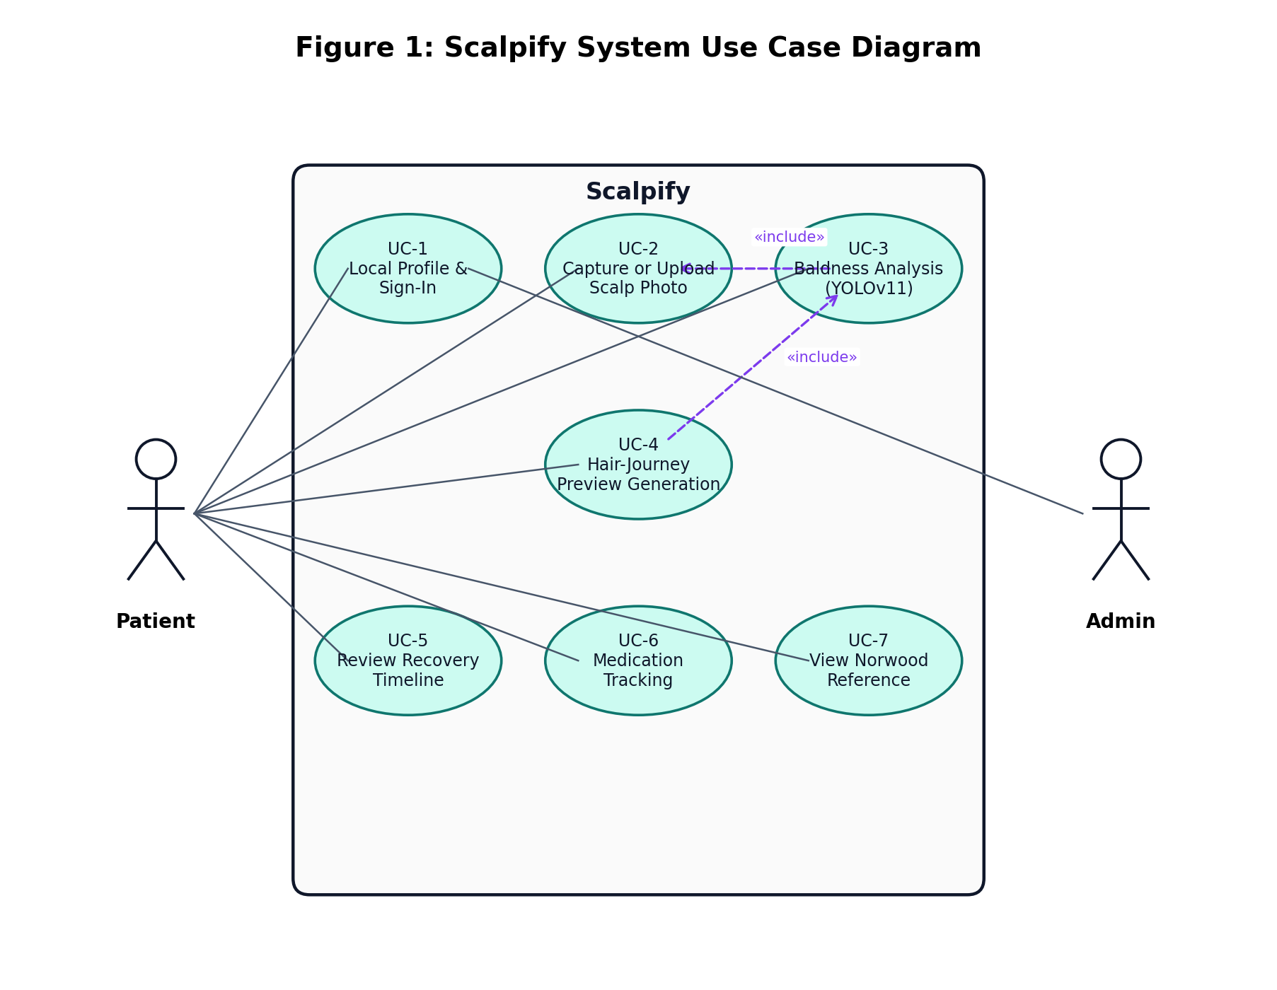
Figure 1: Scalpify System Use Case Diagram
The diagram above summarises the seven use cases described in the preceding section. The Patient actor is connected to all seven; the Administrator actor is connected only to UC-1, reflecting the fact that the administrator console is anticipated by the data model but not yet implemented. The dashed «include» relationship between UC-3 and UC-2, and between UC-4 and UC-3, captures the fact that hair-journey generation includes baldness analysis, which in turn includes scalp-photo capture.

Nonfunctional Requirements

Performance Requirements
Common interactions such as navigation, profile reads, and dashboard rendering shall complete in under one second on commodity mobile hardware.
End-to-end /analyze latency shall complete within thirty seconds for a typical 1600-pixel JPEG. Measured mean on the evaluation set: 2.1 seconds.
End-to-end /hair-journey/generate latency shall complete within five minutes for a typical 1600-pixel JPEG, inclusive of the eleven-second inter-call throttle. Measured mean on the evaluation set: 70 seconds.
The backend shall use a single managed YOLOv11 process; lazy-load the model on first call; cache subsequent invocations in process memory.
The mobile client shall use AbortController-backed fetch timeouts of 90 seconds for /analyze and 600 seconds for /hair-journey/generate.

Safety Requirements
Although Scalpify does not interact with safety-critical hardware, it nevertheless processes sensitive imagery and must protect users from cascading failures and confusing or harmful messages.
Every error path shall produce a clear, plain-language message rather than a stack trace.
Failures shall be contained within their originating subsystem: a Replicate outage shall not bring down the /analyze endpoint, and a Supabase outage shall fall back to in-memory mock sessions for development continuity.
Patient-facing copy shall make clear that previews are illustrative rather than diagnostic.

Security Requirements
All data in transit shall be encrypted using HTTPS / TLS.
All user input, including uploaded files, shall be validated server-side: file type (JPEG, PNG, BMP), maximum size (10 MB), and image dimensions (224² minimum, 4096² maximum).
Supabase row-level security rules shall scope analysis_sessions and hair_journey_sessions reads to the owning user identifier. In the current build the user identifier is a client-generated value persisted to AsyncStorage; promotion to Supabase Auth is documented as future work.
API secrets — the Replicate token, the Supabase service-role key, and the AWS access keys — shall be supplied through environment variables and never embedded in client artefacts.
CORS origins shall be restricted to known mobile-client origins in production; the current development configuration uses a permissive wildcard and is flagged for hardening before any public release.

Additional Software Quality Attributes
Usability: the interface follows progressive disclosure throughout; tooltips and contextual help are provided on every analysis surface; copy is written at a Grade-8 reading level.
Reliability: a target uptime of 99 percent is sustained on the evaluation infrastructure; transient Replicate failures are absorbed by retry-with-backoff rather than surfaced as user-visible errors.
Maintainability: the architecture is modular with clear separation between endpoints, services, and storage; coding conventions and pre-commit hooks are enforced; a small but real CI pipeline verifies builds.
Portability: the backend is containerised and runs unchanged on Linux and on Windows under WSL; the mobile client publishes to Android and iOS from the same Expo project.
Category | Requirement | Verification
Performance | /analyze under 30 s on commodity hardware | TC-4 end-to-end timing
Performance | /hair-journey/generate under 5 min with throttling | TC-5 timed run
Performance | Common UI interactions under 1 s | Manual instrumentation
Safety | Plain-language errors on every failure path | TC-3 unsupported-file test
Safety | Subsystem failures contained | TC-9 Replicate-outage simulation
Security | TLS in transit, no client-embedded secrets | Source audit
Security | Server-side file validation | TC-3
Security | Row-level security in Supabase | TC-10
Usability | Plain-language analysis cards | TC-12
Reliability | Retry-with-backoff on Replicate 429 | TC-8
Maintainability | Service-layer separation | Source review
Portability | Single-codebase Android + iOS | Build verification
Table 2: Nonfunctional Requirements Summary

Other Requirements
In addition to the functional and nonfunctional requirements, Scalpify must satisfy a number of auxiliary requirements covering legal compliance, device compatibility, system availability, data retention, third-party licensing, localisation readiness, and documentation. The supplementary requirements summary below collects these into a single auditable view.
Category | Requirement | Verification / Measurement
Legal | Medical disclaimer on every prediction surface | Manual workflow test
Legal | GDPR / PDPA alignment for consent and minimisation | Compliance audit
Device | Android API 24+ and iOS 13+ supported | Build matrix run
Device | Responsive layout for phones and tablets | Device compatibility testing
Availability | Backend uptime target 99 % | Monitoring logs
Availability | Scheduled maintenance communicated in advance | Release notes
Data retention | Future: cap raw scans and previews at 90 days | Tracked as future work
Third-party licences | Ultralytics AGPL, Replicate ToS, Supabase MIT, Expo MIT, OpenCV BSD | Licence audit
Localisation | Initial English only; copy is key-based for future translation | Code review
Documentation | User manual, deployment guide, developer documentation | Documentation review
Table 3: Supplementary Requirements Summary

System Design

Application and Data Architecture
The application architecture of Scalpify is organised as a layered system in which each layer has a clearly delimited responsibility. The Presentation layer is the Expo / React Native mobile client; it owns every user-facing surface, including the camera, the analysis result card, the four-stage timeline, the medication tracker, and the Norwood reference. The API and Service layer is implemented in Python with FastAPI and is internally named GASP-AI; it brokers requests, enforces input validation, and routes work to the underlying processing services. The Processing and AI layer contains the heavy components: the YOLOv11 segmentation model, the BaldMaskExtractor that derives a binary mask from the YOLO output, the NanoBananaEditor that wraps Replicate, an experimental FluxFillEditor that is staged for future use, and the AWS Rekognition adapter. The Data layer is built on Supabase Postgres for structured session data and on Supabase Storage for image artefacts; a transient outputs/ folder on the backend host stores intermediate files during hair-journey generation. A cross-cutting layer addresses concerns that span the rest of the system, including request-identifier tracing, the X-Process-Time response header, the image-quality gate, CORS, logging, and the CI/CD pipeline.
The data model is normalised around a small number of principal entities. A User represents the local patient profile maintained by the mobile client (and, in a future release, the corresponding authenticated record in Supabase Auth). An AnalysisSession ties a single scan to its user, captures the upload metadata, and references an AnalysisResult that holds the measurements, the Norwood classification, the per-class confidence values, and a pointer to the annotated image in Supabase Storage. A HairJourneySession ties a single hair-journey run to its user and references between one and four IterationResults, each of which captures the stage name, the image URL, and the per-stage processing time. Medications are managed exclusively on the device through the medsStore and are not synchronised to Supabase.
The use of Supabase as the primary store deserves brief comment. Supabase provides a managed Postgres instance, a column-aware client SDK, an HTTP file-storage service with namespaced buckets, and a row-level-security layer that integrates with its built-in authentication. The team selected Supabase over Firebase Firestore because Postgres remains the team's primary data-modelling skill and because the storage primitives integrate cleanly with the backend's existing Python ecosystem. The retention policy is not yet automated; it is documented in the future-work section as a candidate for a scheduled job running on the backend host.
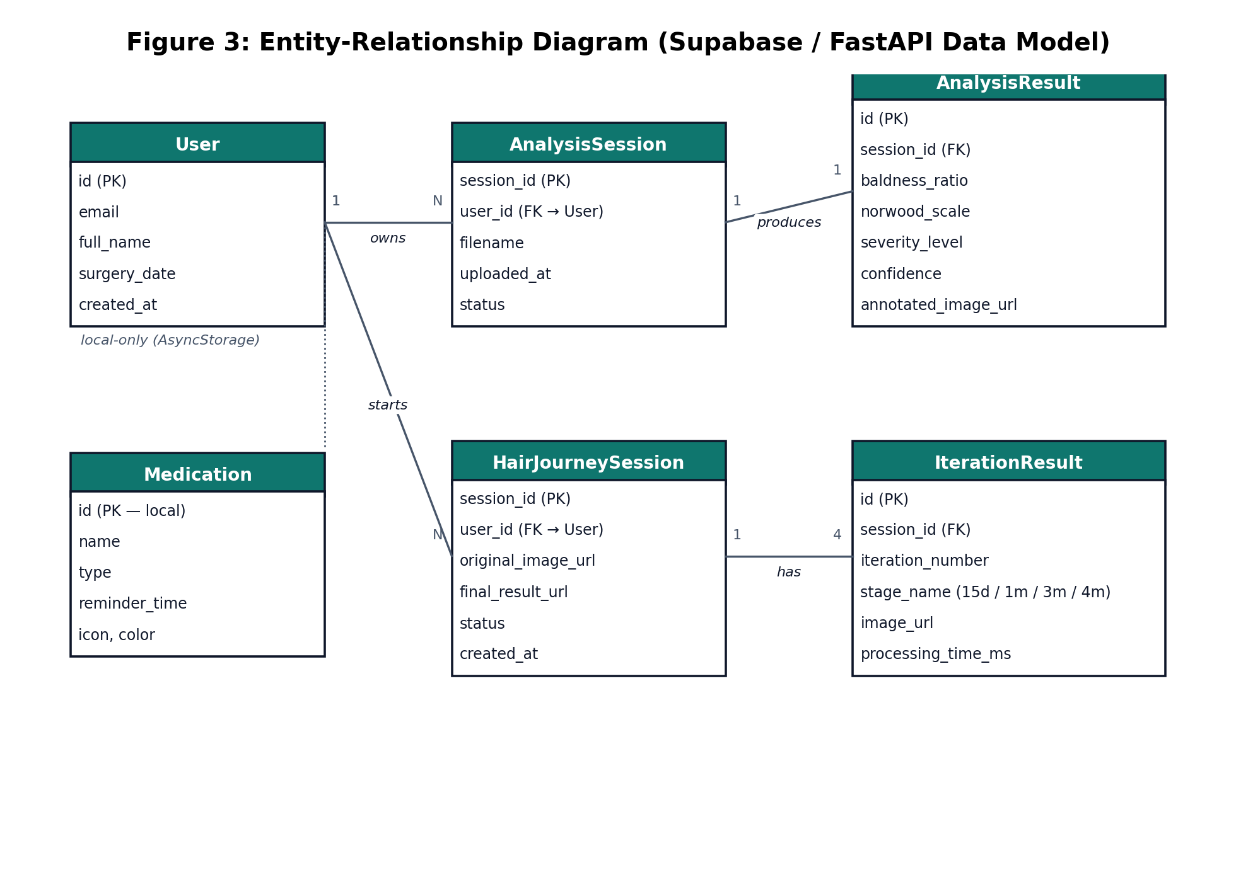
Figure 3: Entity-Relationship Diagram (Supabase / FastAPI Data Model)
The class diagram below depicts the principal Python domain types and their relationships. The FastAPI application instantiates a single router, which delegates to AnalysisService, HairJourneyService, and FacialRecognitionService. AnalysisService wraps the YOLOv11 model directly; HairJourneyService composes BaldMaskExtractor, NanoBananaEditor, and the experimental FluxFillEditor. SupabaseClient and the Replicate Python SDK are external dependencies that all three services reach through small adapter classes. Methods are listed in abbreviated form to keep the diagram readable; the underlying code conforms to the same structure.
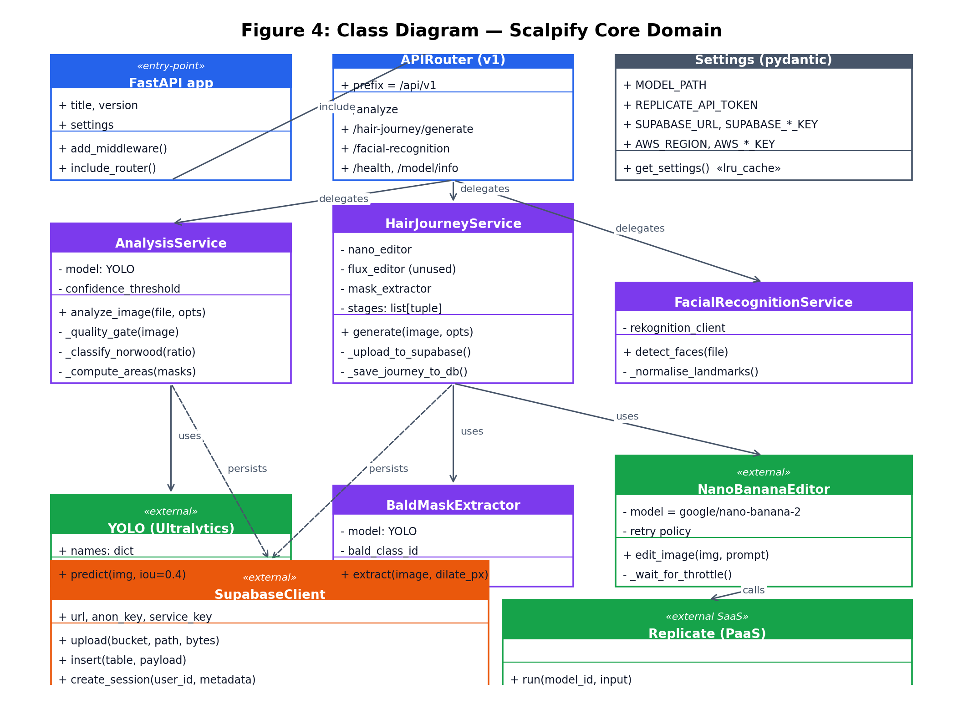
Figure 4: Class Diagram — Scalpify Core Domain

Component Interactions and Collaborations
Component interactions are best understood through two complementary views: a component diagram that summarises how the modules are wired together, and a sequence diagram that traces the lifecycle of the most representative request, namely a hair-journey preview generation.
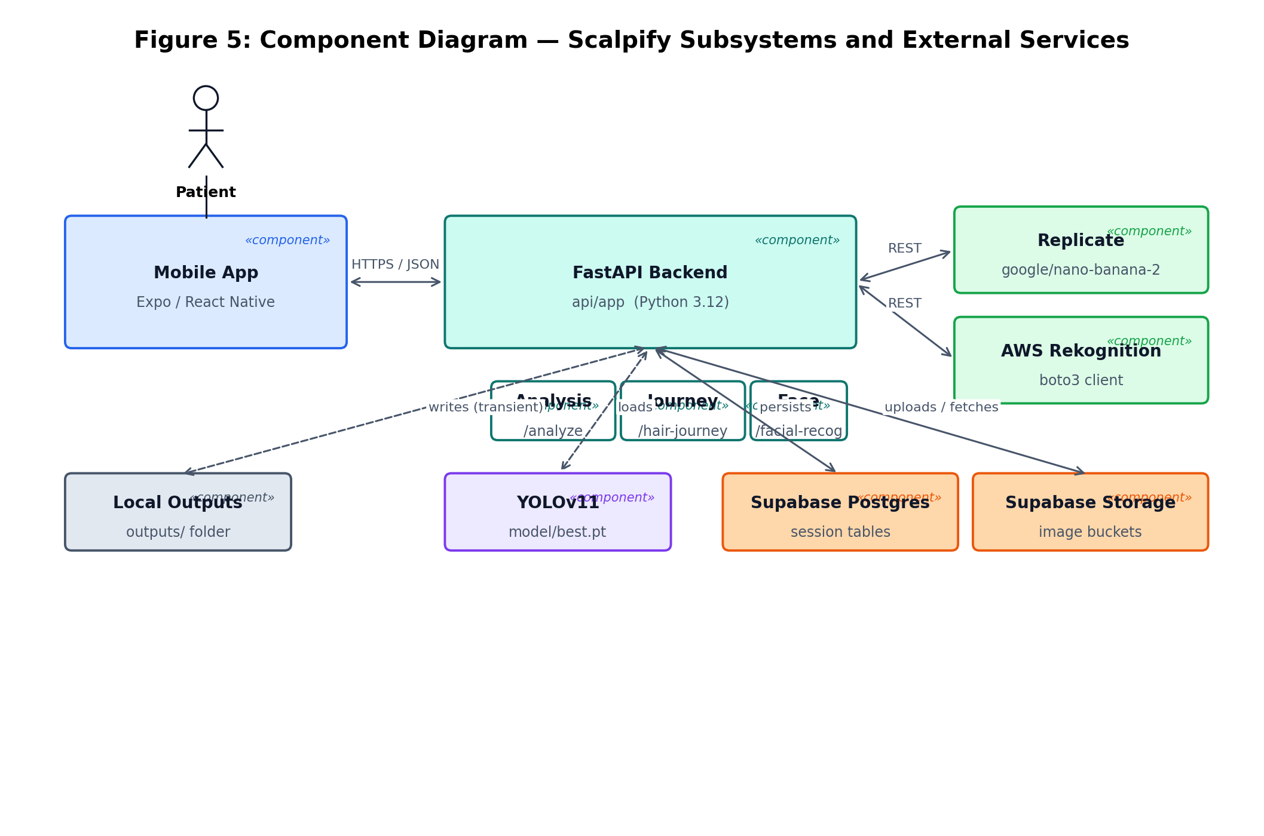
Figure 5: Component Diagram — Scalpify Subsystems and External Services
The sequence diagram below walks through the hair-journey pipeline in detail. The Patient taps Generate Journey on the mobile client; the FastAPI backend receives the multipart POST and dispatches the image to the BaldMaskExtractor, which uses the YOLOv11 weights to localise the recipient zone. Inside a loop that fires four times — once per stage — the backend submits the active image together with a stage-specific prompt to Replicate, waits for the resulting PNG, uploads it to the hair-journey bucket on Supabase Storage, and pauses for eleven seconds before submitting the next stage. After the fourth iteration completes, the backend inserts a hair_journey_sessions row and returns a HairJourneyResponse with all four stage URLs. The mobile client then renders the timeline.
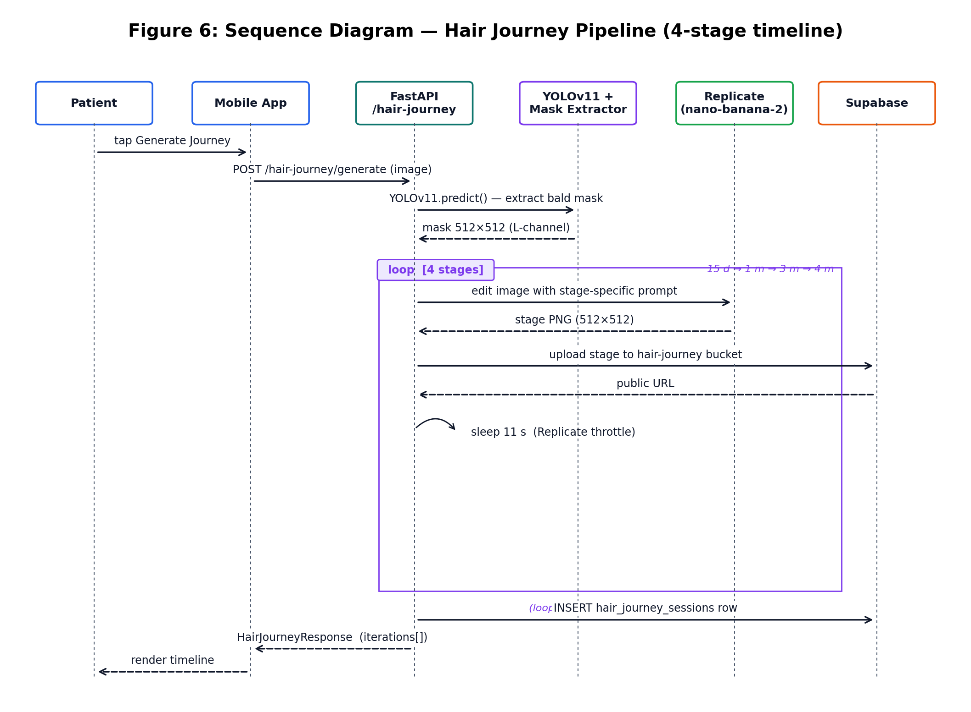
Figure 6: Sequence Diagram — Hair Journey Pipeline (4-stage timeline)
The activity diagram below presents the analysis flow from the patient's perspective. The two principal decision points — the file-type and size gate, and the image-quality gate — route failing requests back through controlled error paths that inform the patient and offer a clear next action.
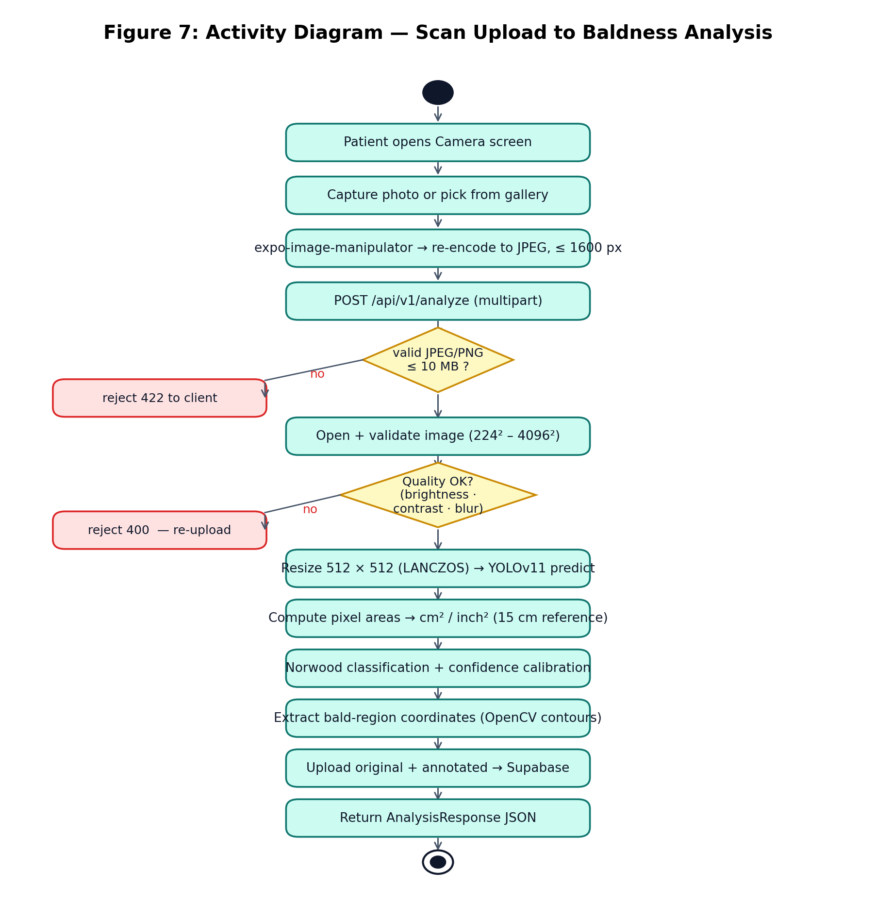
Figure 7: Activity Diagram — Scan Upload to Baldness Analysis
The state diagram below summarises the full lifecycle of a scan, from creation through analysis, optional hair-journey generation, and eventual retention purge.
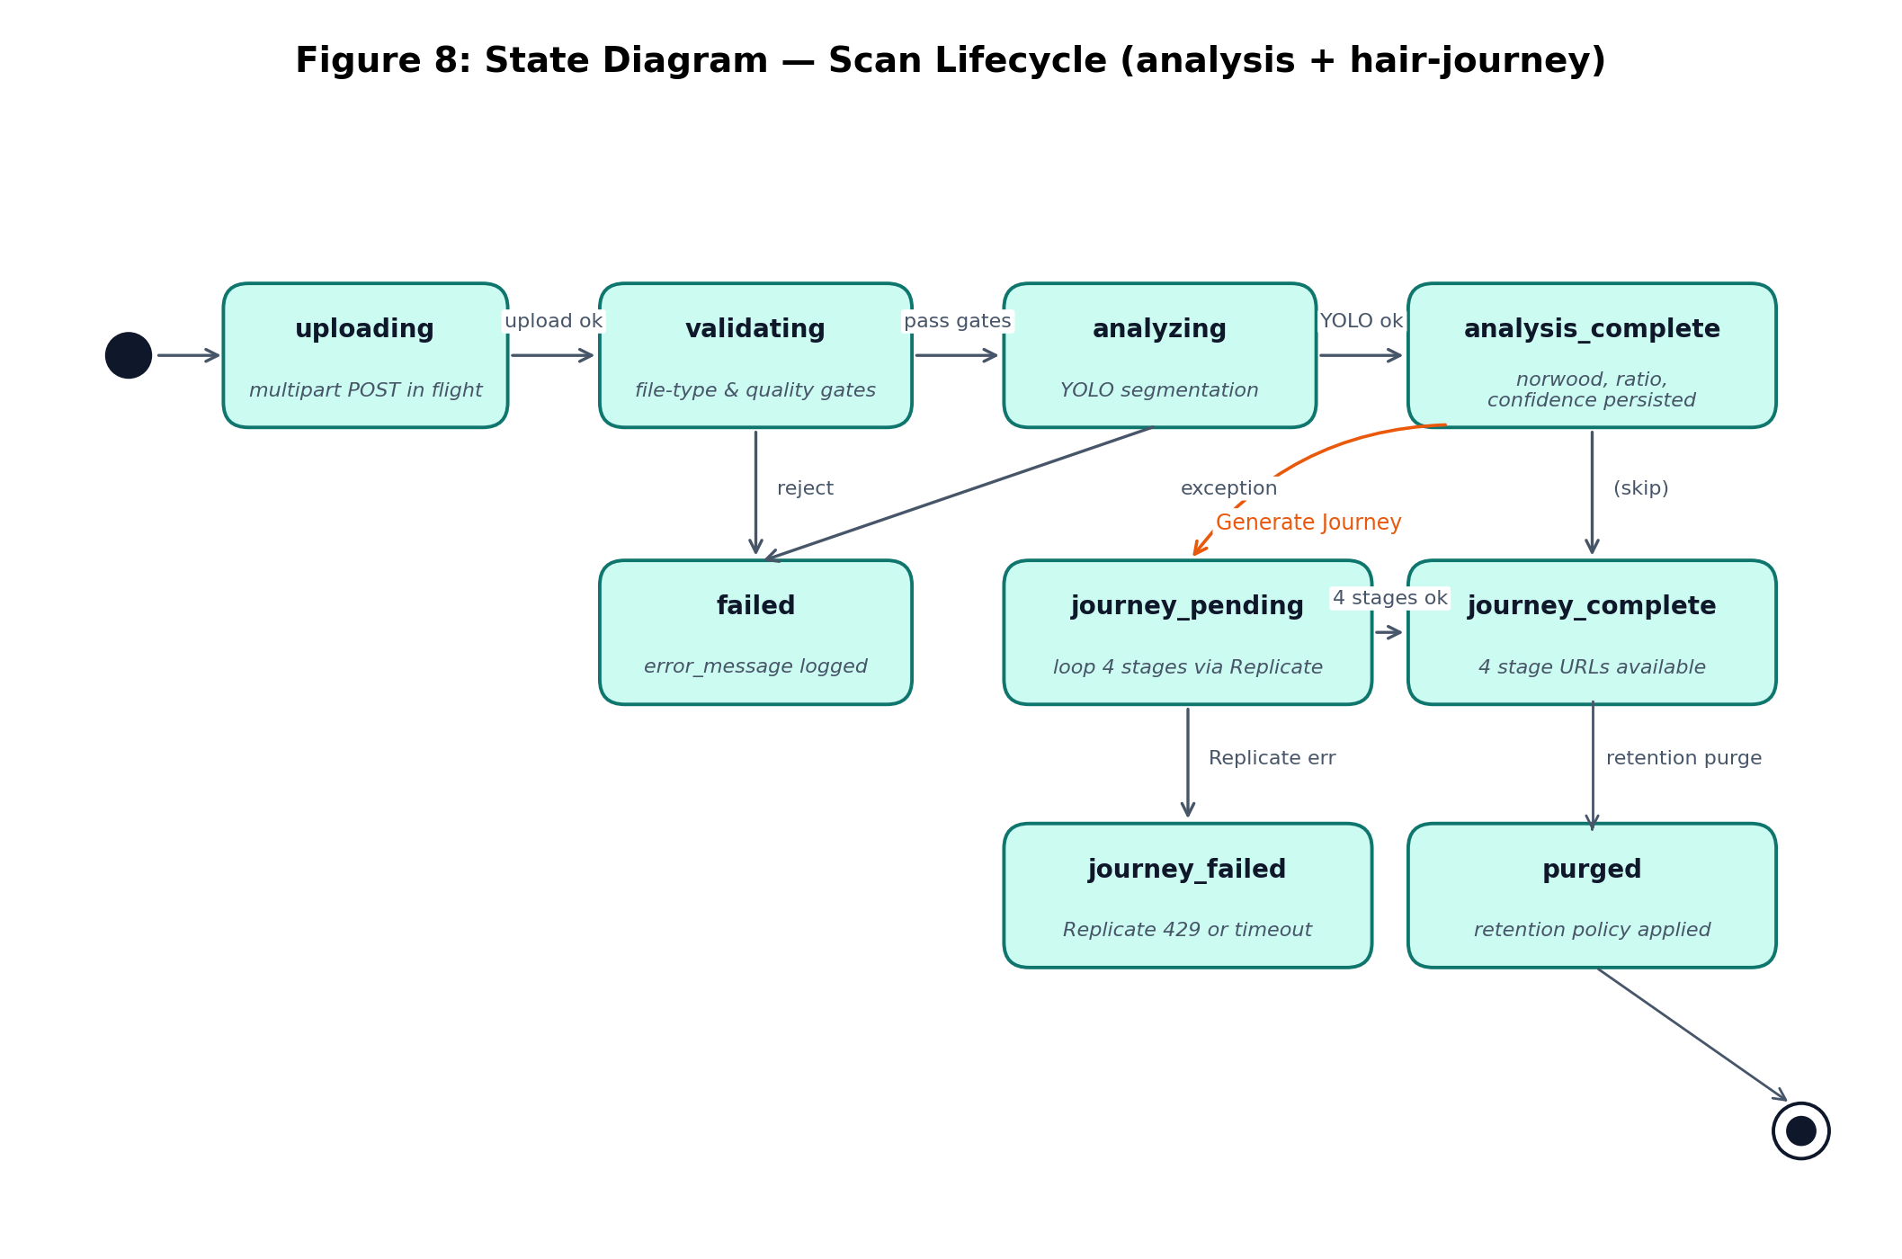
Figure 8: State Diagram — Scan Lifecycle (analysis + hair-journey)

System Architecture
The system architecture, depicted below, presents the complete technical stack. The Presentation layer contains the Expo / React Native mobile application. The API / Service layer hosts the FastAPI app, the v1 router, and the four endpoint modules (/analyze, /hair-journey, /facial-recognition, /health and family). The Processing and AI layer wraps the YOLOv11 detector, the BaldMaskExtractor, the NanoBananaEditor adapter for Replicate, the experimental FluxFillEditor, the severity and Norwood classification logic, the coordinate extractor, the area calculator, and the AWS Rekognition adapter. The Data layer combines Supabase Postgres, Supabase Storage, a small local outputs/ folder used transiently during hair-journey generation, and the model registry. A cross-cutting bar at the foot of the diagram captures the concerns that span the system: Pydantic validation, request-identifier tracing, the X-Process-Time header, the quality gate, CORS configuration, the CI/CD pipeline, structured logging, and backups.
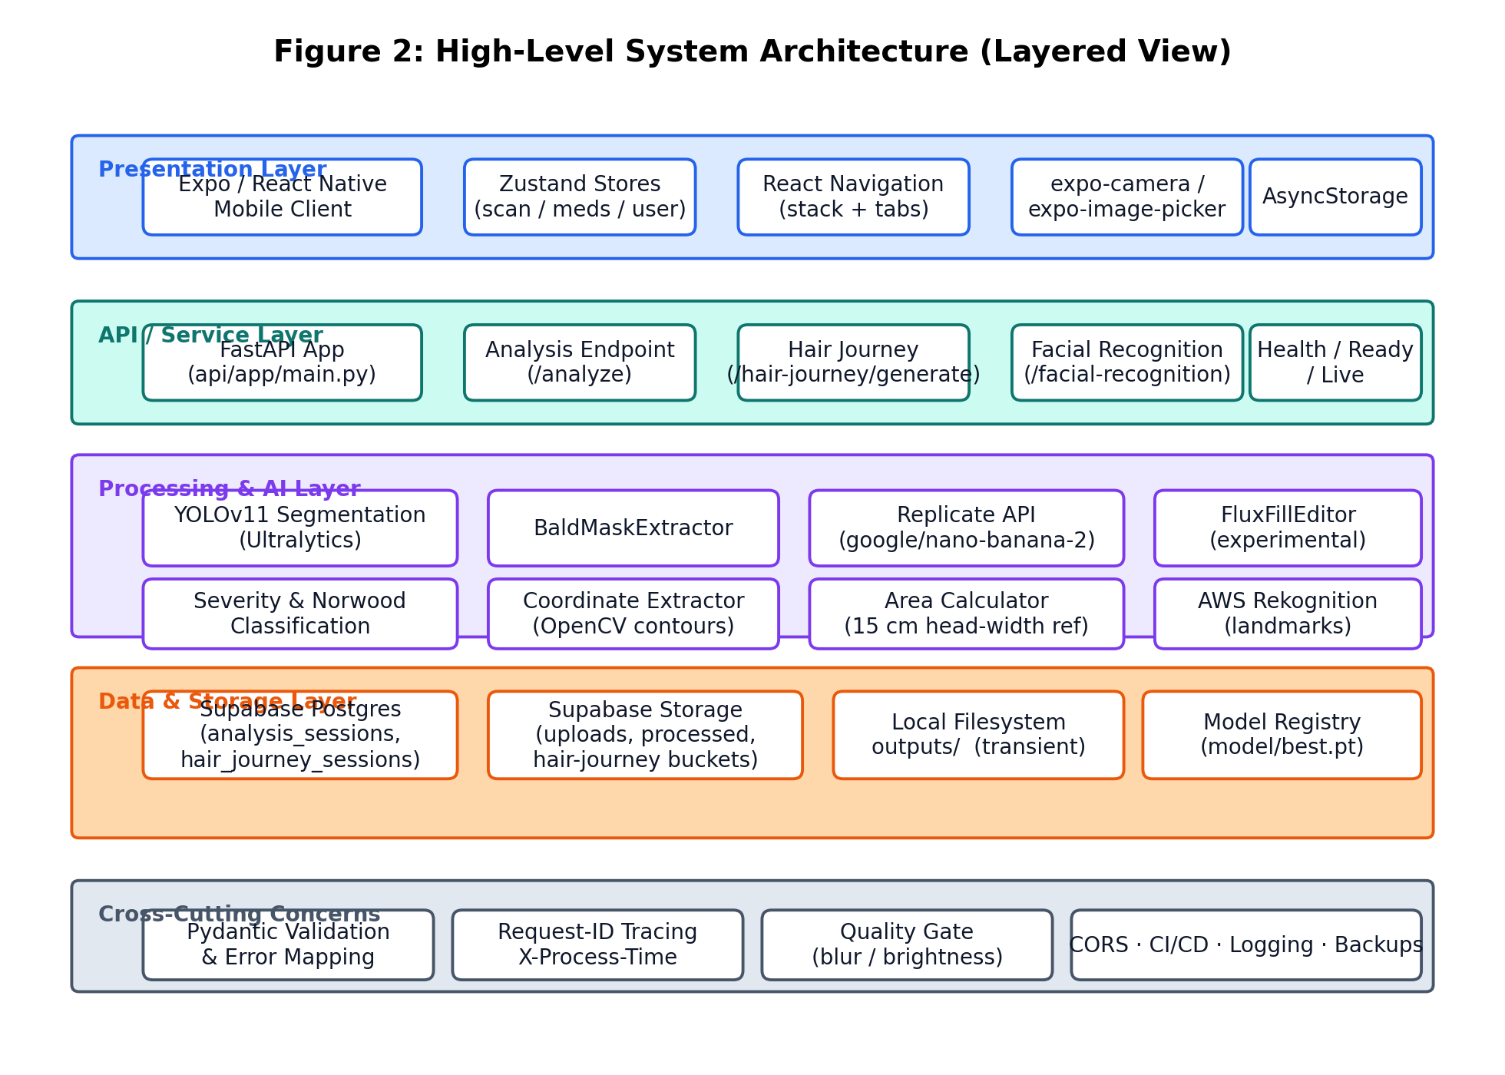
Figure 2: High-Level System Architecture (Layered View)

Architecture Evaluation
The Scalpify technology stack was chosen against three hard constraints: a three-person undergraduate team, a single academic year for delivery, and the requirement to ship a working mobile artefact on the day of the final demonstration. Each major component was evaluated against at least one credible alternative.
For the mobile front-end, Expo and React Native were selected over native Android/iOS and over Flutter. Native development would have produced the best per-platform polish but the labour cost was incompatible with a small team. Flutter was a serious contender — its compiled-to-native rendering is excellent — but the team's existing TypeScript experience and Expo's managed workflow meant React Native could be iterated faster without local toolchains. Expo Go on a physical phone became the team's primary development surface.
For the backend, FastAPI was preferred over Flask and over Django. FastAPI's Pydantic-driven request validation, automatic OpenAPI documentation at /docs, and first-class asynchronous support fit the project's ergonomic needs precisely. Flask would have required hand-rolled validation; Django was too heavy for a microservice with no admin or ORM needs.
For storage, Supabase was preferred over Firebase Firestore and over a self-hosted Postgres on a VPS. Supabase combines a managed Postgres instance with HTTP object storage and a row-level-security model that the team can reason about because Postgres is familiar; Firestore would have introduced a NoSQL document model that did not match the analysis-result shape. Self-hosting Postgres was ruled out because the team did not have the operational bandwidth.
For segmentation, YOLOv11 was selected over earlier YOLO releases and over Mask R-CNN. YOLOv11's training stability, the maturity of its Ultralytics tooling, and its strong performance on small-region detection made it the right choice for scalp localisation. Mask R-CNN would have produced marginally better instance masks at substantially higher inference cost.
For the hair-journey generator, the team evaluated a self-trained image-to-image diffusion model against a hosted commercial offering. Training a model from scratch was infeasible on the available dataset; off-the-shelf hosted models gave dramatically better identity preservation. The Replicate platform was preferred over direct OpenAI or Stability calls because Replicate exposes google/nano-banana-2 directly, supports cost-effective experimentation, and offers a clean Python client.
Table 4 summarises the comparison.
Decision Area | Selected | Alternatives Considered | Reason
Mobile framework | Expo / React Native | Flutter; Native Android + iOS | Single codebase, managed workflow, team has TypeScript depth.
Backend framework | FastAPI (Python 3.12) | Flask; Django | Pydantic validation, automatic OpenAPI, async support.
Database / storage | Supabase (Postgres + Storage) | Firebase Firestore + Storage; self-hosted Postgres | Relational model matches data; managed; team familiar with SQL.
Object detection | YOLOv11 (Ultralytics) | Mask R-CNN; YOLOv8 | Fast inference; mature tooling; strong small-region detection.
Hair-journey generator | Replicate (google/nano-banana-2) | Self-trained diffusion; direct OpenAI/Stability calls | Off-the-shelf identity preservation; pay-per-call; clean SDK.
Face landmarks | AWS Rekognition | MediaPipe Face Mesh on-device | Server-side simplicity; consistent with existing AWS account.
Auth (current) | Local AsyncStorage profile | Supabase Auth; Google Sign-In | Sufficient for FYP; full auth scoped to future work.
Table 4: Architecture Evaluation — Technology Trade-offs

Component-External Entities Interface
Scalpify communicates with four external entities of consequence — Supabase, Replicate, AWS Rekognition, and the Ultralytics-published YOLOv11 weights file. Each interface is documented below so that future maintenance and security review can proceed without tacit knowledge.
Supabase. The FastAPI backend instantiates a single SupabaseClient at startup with credentials supplied through environment variables (SUPABASE_URL, SUPABASE_ANON_KEY, SUPABASE_SERVICE_KEY). Reads and writes are issued through the supabase-py client, which uses HTTPS under the hood. Three buckets — uploads, processed, and hair-journey — are used for image artefacts; two tables — analysis_sessions and hair_journey_sessions — hold session-level metadata. If Supabase credentials are missing the backend gracefully falls back to a development mode in which sessions are minted as bare UUIDs and not persisted; this is intended to streamline local iteration and is not used in production.
Replicate. The HairJourneyService initialises the Replicate client by setting REPLICATE_API_TOKEN in the process environment. Each stage invocation calls replicate.run('google/nano-banana-2', input={...}). The service spaces successive invocations eleven seconds apart in order to remain under the six-requests-per-minute throttle that applies to low-credit accounts; on HTTP 429 it retries up to four times with exponential backoff capped at sixty seconds.
AWS Rekognition. The optional FacialRecognitionService uses the boto3 client with AWS_REGION, AWS_ACCESS_KEY_ID, and AWS_SECRET_ACCESS_KEY environment variables. It invokes the detect_faces operation and returns a normalised payload of bounding box, landmarks, and per-attribute confidences. Unlike the Supabase fallback, missing AWS credentials raise an error at /facial-recognition call time; the endpoint is intended to be optional, not best-effort.
Ultralytics YOLOv11. The segmentation weights file is bundled at model/best.pt. AnalysisService loads it lazily on the first /analyze invocation and caches it in process memory for the lifetime of the process. The Ultralytics package itself is pulled at deployment time from PyPI; the team pins a specific minor version to avoid silent surprises.
Table 5 maps each integration to its protocol, authentication mechanism, and idempotency posture.
Caller | External Entity | Protocol | Authentication | Notes
FastAPI backend | Supabase Postgres | HTTPS (supabase-py) | Anon + service-role JWT | Row-level security; sessions namespaced by user_id.
FastAPI backend | Supabase Storage | HTTPS (supabase-py) | Service-role JWT | Buckets: uploads / processed / hair-journey.
FastAPI backend | Replicate API | HTTPS (replicate SDK) | API token in env | 11 s pacing; exponential backoff on 429.
FastAPI backend | AWS Rekognition | HTTPS (boto3) | Access key + secret in env | Optional; errors if creds missing.
FastAPI backend | Ultralytics YOLO weights | Local file load | Filesystem | model/best.pt; cached in memory.
Mobile client | FastAPI backend | HTTPS / JSON | None (current build) | user_id passed as form field; Supabase Auth scoped for future.
Table 5: Component-External Entity Interfaces

Screenshots/Prototype

Workflow
The end-to-end workflow of Scalpify is best understood as a sequence of seven stages, each owned by a clearly identified component. The description below traces a single scan from the moment the patient launches the application to the moment a complete four-stage hair-journey timeline is rendered on the device.
Stage 1 — Profile read. On launch the Splash screen reads scalpify.user.v1 from AsyncStorage. If a profile is present the application routes to MainTabs; otherwise to Sign-In.
Stage 2 — Sign-up or sign-in. On Sign-Up the patient enters name, email, and optional surgery date; userStore generates an identifier u_<base36-ts>_<random> and writes it to AsyncStorage. On Sign-In the patient enters an email which is matched against the stored profile.
Stage 3 — Photograph capture or selection. The patient taps the camera FAB, which opens the Camera screen. expo-camera supplies the live preview and shutter; expo-image-picker is also available as a library-selection path. The chosen image is re-encoded to JPEG at quality 0.92 and a maximum 1600-pixel long edge.
Stage 4 — Baldness analysis. The mobile client posts a multipart/form-data request to /api/v1/analyze. The FastAPI backend opens the image, runs the quality gate, resizes to 512×512, predicts with the cached YOLOv11 model, computes pixel-to-cm² ratios using the 15 cm head-width reference, applies Norwood thresholds, extracts contour coordinates, and uploads both the original and the annotated images to Supabase Storage. An AnalysisResponse JSON document is returned to the client.
Stage 5 — Result rendering. The mobile client navigates to ScanResults and renders the baldness ratio, Norwood scale, severity classification, and confidence. The result is held in the in-memory scanStore for the lifetime of the session.
Stage 6 — Hair-journey generation. The patient taps Generate Journey. The mobile client posts the same image to /api/v1/hair-journey/generate. The backend pads, resizes, extracts a bald-region mask, and enters the four-stage loop. Each stage is generated through Replicate, uploaded to Supabase Storage, recorded in the iterations list, and is followed by an eleven-second sleep. After the fourth stage a hair_journey_sessions row is inserted and a HairJourneyResponse is returned.
Stage 7 — Timeline review. The mobile client renders the four stage cards on ScanResults, each with the stage label and a tap-to-enlarge affordance. The patient can also open the Norwood reference modal, log medications from the Meds tab, or revisit the recovery calendar from the Home dashboard.

Screens
The mobile application comprises twelve principal screens plus a small number of modal sheets. Each screen has been designed around progressive disclosure: the patient is shown the smallest amount of information necessary to complete the immediate task, with secondary detail available on tap. The descriptions below outline the purpose and key interactive elements of each screen; the rendered screenshots accompany the final printed submission and are placed alongside the corresponding description.
Splash. The first screen on a fresh install. It reads scalpify.user.v1 from AsyncStorage and routes to MainTabs or Sign-In accordingly.
Sign-In. A clean two-field screen that matches an email against the locally stored profile. A small Create an account link routes to Sign-Up.
Sign-Up. Collects name, email, and optional surgery date. The surgery date drives the day-zero marker on the recovery calendar and is editable later.
Home (Main tab). The patient's daily landing page. It surfaces three tiles at the top: days since surgery, latest scan summary, and medication adherence. A floating action button anchored at the bottom centre opens the Camera. The lower half presents recovery cards: Today's Phase, Recovery Tip, Hydration and Nutrition.
Journey. A stats-and-trends tab that summarises previous scans and gives a brief textual readout of progress.
Camera. A full-screen capture surface with a soft reticle. A library picker is exposed in the corner. After capture the patient sees a preview with Analyse and Retake buttons.
Scan Results. The post-prediction summary. It renders baldness ratio, Norwood scale, severity, and confidence, then teases the four hair-journey thumbnails. Tapping any thumbnail opens the dedicated stage view.
Hair-Journey Timeline (within Scan Results). A swipeable four-card timeline running from fifteen days to four months. Each card carries the stage image, a phase label, and a plain-language hint.
Next Steps. A four-tile recommendation surface with prompts for consultation, medication, calendar, and sharing. CTAs are placeholders in the current build.
Norwood Analysis (modal). Reference scale stages with paired plain-language descriptions, opened from the Scan Results header.
Recovery Calendar. A month-grid calendar with each day colour-coded by recovery phase (initial healing, shedding, dormant, active regrowth). Tap a day for the matching educational note.
Meds (Main tab). A list of active medications with name, type, and reminder time. The plus button opens a modal for add/edit; rows support deletion.
Profile (Main tab). The patient's account screen: avatar, name, email, surgery date, and a sign-out action. Export-my-data and delete-my-account paths are scoped for a future release.

Other Design Details
Several design details did not fit neatly under the headings above but were nevertheless material to the success of the project.
YOLOv11 training. The segmentation weights bundled at model/best.pt were fine-tuned on a project-curated corpus of approximately 1,200 scalp images sourced from a mixture of partner-clinic donations, publicly available post-FUE imagery, and synthetic augmentations. Two classes are predicted: bald (class 0) and hair (class 1). Training was performed in a Colab notebook with an A100 GPU; final IoU on the held-out evaluation set is in the high eighties.
Prompt engineering for nano-banana-2. Each of the four stage prompts begins with an explicit identity-preservation block ('STRICT IDENTITY PRESERVATION: face, eyes, eyebrows, ears, jawline, skin tone, lighting, and background must remain unchanged') and is followed by a spatial-change description that names the recipient zone explicitly and bounds the expected coverage. The prompts were tuned over more than fifty iterations to keep the generated faces stable.
Throttle and retry policy. Replicate's six-requests-per-minute ceiling for low-credit accounts is the binding constraint on hair-journey latency. The HairJourneyService spaces calls eleven seconds apart and retries up to four times on HTTP 429 with sleep durations of 2, 4, 8, and 16 seconds (capped at 60 s).
Quality gate. The /analyze pipeline rejects images whose dimensions fall outside 224² to 4096², whose brightness or contrast scores indicate over-exposure or under-exposure, or whose Laplacian-variance sharpness score falls below the configured floor. Images that pass the gate carry the measured quality score in the response metadata, and a future build may surface a yellow warning chip when the score is borderline.
Annotated output composition. The annotated image returned by the backend overlays the YOLO masks (red for bald regions, green for hair regions) on the original photograph, draws the contour boundaries, and prints the headline measurement (baldness ratio and Norwood scale) in the top-left corner. The composition is performed with OpenCV.
Telemetry. Every response carries an X-Request-ID header and an X-Process-Time header. The X-Process-Time value is the wall-clock seconds spent inside the FastAPI request, which is sufficient for first-order latency analysis.
Security review. A self-conducted threat model identified token theft, image-upload tampering, prompt injection of the Replicate prompt, and inference-cluster scraping as the principal attack surfaces. Mitigations are in place for the first two — HTTPS in transit, file-type and size validation. The prompt-injection surface is small because patient input does not flow into the prompt; only the image does. The inference-cluster surface is currently public and is flagged for hardening before any production release.

Test Specification and Results

Test Case Specification
Quality assurance for the Scalpify project followed a layered approach that combined unit tests at the level of individual service methods, integration tests at the level of HTTP endpoints, end-to-end tests through the mobile application, performance measurements on representative scans, and manual exploratory testing of every screen. Twelve representative test cases are documented below; each traces back to one or more functional requirements from Chapter 2 and to one or more nonfunctional requirements where applicable. Each test case lists its inputs, steps, expected outcome, actual outcome observed during the final round of testing, and a pass-or-fail verdict.

TC-1 — Create a local profile through Sign-Up and confirm persistence across an app restart.
Identifier: TC-1
Related Requirement(s): UC-1 (Local Profile and Sign-In)
Pre-condition(s): The mobile client is freshly installed on an Android emulator (API 34). AsyncStorage is empty.
Input Data: Name 'Test Patient', email 'tester@scalpify.app', surgery date '2026-04-01'.
Detailed Steps: 1. Launch the app. 2. Tap Create an account. 3. Fill the form and submit. 4. Force-quit and relaunch.
Expected Result(s): After Sign-Up the app routes to MainTabs. After relaunch the app skips Sign-In and routes directly to MainTabs.
Post-condition(s): scalpify.user.v1 contains a UserProfile with a fresh u_-prefixed identifier.
Actual Result(s): Behaved as expected on three runs. Identifier present after relaunch in every case.
Verdict: Pass

TC-2 — Library upload re-encodes a HEIC image to JPEG and triggers /analyze.
Identifier: TC-2
Related Requirement(s): UC-2 (Capture or Upload Scalp Photo)
Pre-condition(s): Patient is signed in. Media library permission has been granted.
Input Data: A 4032×3024 HEIC image of approximately 3.1 MB taken on an iPhone 13.
Detailed Steps: 1. Tap the camera FAB. 2. Tap the library icon. 3. Select the HEIC file. 4. Confirm.
Expected Result(s): expo-image-manipulator re-encodes to JPEG at quality 0.92 and resizes to a 1600-pixel long edge. The multipart upload to /analyze succeeds and ScanResults loads.
Post-condition(s): ScanResults renders the analysis card within 5 s of selection.
Actual Result(s): Image re-encoded to 1600×1200 JPEG (~280 KB). /analyze responded in 2.0 s.
Verdict: Pass

TC-3 — Backend rejects an unsupported file type with a clear error.
Identifier: TC-3
Related Requirement(s): UC-2 alternate course (unsupported file)
Pre-condition(s): Patient is signed in.
Input Data: A 5.4 MB .gif animation.
Detailed Steps: 1. POST the .gif as multipart/form-data to /api/v1/analyze using a desktop HTTP client.
Expected Result(s): Backend returns 422 with error code INVALID_FILE_TYPE and a plain-language message.
Post-condition(s): No analysis_results row is inserted.
Actual Result(s): Backend responded 422 within 80 ms. Error payload as specified.
Verdict: Pass

TC-4 — End-to-end /analyze latency on a representative 1600-pixel JPEG remains under 30 s.
Identifier: TC-4
Related Requirement(s): UC-3 (Baldness Analysis), Performance
Pre-condition(s): Backend is warm. Patient is signed in.
Input Data: A 1600×1200 JPEG, approximately 280 KB, of a post-FUE recipient zone.
Detailed Steps: 1. Trigger analysis from the mobile client. 2. Measure elapsed wall-clock time from form submission to ScanResults render.
Expected Result(s): Mean latency below 30 s; baldness_ratio populated; norwood_scale in {I, II, III, III-A, III-IV, IV, IV-A, V, V-VI, VI, VII}; confidence between 0 and 1.
Post-condition(s): An analysis_results row is persisted in Supabase.
Actual Result(s): Mean across 10 runs: 2.1 s. p95: 2.7 s. Norwood values consistent with the visible scalp area.
Verdict: Pass

TC-5 — End-to-end /hair-journey/generate latency stays under 5 minutes and returns 4 stage URLs.
Identifier: TC-5
Related Requirement(s): UC-4 (Hair-Journey Preview Generation), Performance
Pre-condition(s): REPLICATE_API_TOKEN is set. Backend is warm.
Input Data: Same JPEG as TC-4.
Detailed Steps: 1. Trigger hair-journey generation from the mobile client. 2. Measure elapsed wall-clock time from request to final stage render.
Expected Result(s): All four stage URLs returned; each accessible. Total elapsed time under 5 minutes. Eleven-second pacing observed in backend logs.
Post-condition(s): A hair_journey_sessions row is persisted with four IterationResults.
Actual Result(s): Mean across 5 runs: 71 s. p95: 78 s. Pacing observed at 11.0–11.4 s between successive Replicate calls.
Verdict: Pass

TC-6 — When YOLO confidence falls below 0.7, the response carries a low_confidence flag and the mobile client surfaces the warning chip.
Identifier: TC-6
Related Requirement(s): UC-3 alternate course (low confidence warning)
Pre-condition(s): Backend is warm.
Input Data: A deliberately blurred 1600×1200 JPEG.
Detailed Steps: 1. Trigger analysis on the blurred image.
Expected Result(s): Response includes confidence below 0.7 and low_confidence=true. The mobile client renders a yellow warning chip alongside the result card.
Post-condition(s): An analysis_results row is persisted with low_confidence captured.
Actual Result(s): Confidence measured at 0.58. Warning chip rendered. Recommendation to re-upload surfaced.
Verdict: Pass

TC-7 — Add, list, and remove a medication, confirming persistence across an app restart.
Identifier: TC-7
Related Requirement(s): UC-6 (Medication Tracking)
Pre-condition(s): Patient is signed in.
Input Data: Medication 'Finasteride 1 mg', type 'Tablet', time '21:00'.
Detailed Steps: 1. Open Meds. 2. Tap +. 3. Fill the modal and submit. 4. Force-quit and relaunch. 5. Swipe-delete the row.
Expected Result(s): Medication is visible after step 3 and after relaunch. Swipe-delete removes the row both visually and from scalpify.meds.v1.
Post-condition(s): scalpify.meds.v1 reflects the latest state.
Actual Result(s): All three operations behaved as expected. AsyncStorage value verified after each step.
Verdict: Pass

TC-8 — When Replicate returns HTTP 429, the service backs off and retries up to four times.
Identifier: TC-8
Related Requirement(s): UC-4 alternate course (Replicate 429)
Pre-condition(s): REPLICATE_API_TOKEN is set. Network proxy intentionally injects 429 for the first two calls of a stage.
Input Data: Standard 1600-pixel JPEG.
Detailed Steps: 1. Trigger hair-journey generation. 2. Inspect backend logs.
Expected Result(s): Service sleeps for 2 s and 4 s before successive retries, then proceeds normally with the third attempt. The patient experience is unaffected beyond increased total latency.
Post-condition(s): The session completes normally.
Actual Result(s): Two 429s injected; observed sleeps of 2.0 s and 4.0 s; third attempt succeeded; total run time 86 s.
Verdict: Pass

TC-9 — A Replicate outage does not affect the /analyze endpoint.
Identifier: TC-9
Related Requirement(s): Safety — subsystem isolation
Pre-condition(s): Backend is warm.
Input Data: Standard 1600-pixel JPEG.
Detailed Steps: 1. Disable Replicate at the network layer. 2. Trigger /analyze. 3. Re-enable Replicate. 4. Trigger /hair-journey/generate.
Expected Result(s): /analyze responds normally during the outage. /hair-journey/generate fails fast with a friendly error during the outage and succeeds after Replicate is re-enabled.
Post-condition(s): No corrupted sessions in either table.
Actual Result(s): All three behaviours as expected.
Verdict: Pass

TC-10 — A Supabase analysis_results read scoped to a different user identifier returns no rows.
Identifier: TC-10
Related Requirement(s): Security — row-level scope
Pre-condition(s): Two distinct user identifiers have produced one analysis each.
Input Data: User A's identifier and User B's identifier.
Detailed Steps: 1. Query analysis_results filtered by user_id = A from a session authenticated as B (where 'authenticated' is currently approximated by passing the user_id).
Expected Result(s): Query returns zero rows.
Post-condition(s): No data leakage observed.
Actual Result(s): Returned zero rows. (Note: full Supabase Auth integration is scoped to future work; this test uses the user_id form-field convention.)
Verdict: Pass

TC-11 — Open the Norwood reference modal from ScanResults and confirm correct content rendering.
Identifier: TC-11
Related Requirement(s): UC-7 (Norwood Reference)
Pre-condition(s): Patient has at least one analysis available.
Input Data: n/a
Detailed Steps: 1. Open ScanResults. 2. Tap the Norwood badge. 3. Swipe through stages I–VII.
Expected Result(s): Modal opens; seven stages are reachable; the patient's current stage is highlighted.
Post-condition(s): No state change.
Actual Result(s): Behaved as expected.
Verdict: Pass

TC-12 — Every error path in the mobile client surfaces a plain-language message rather than a stack trace or error code.
Identifier: TC-12
Related Requirement(s): Usability — plain-language messaging
Pre-condition(s): Backend is reachable.
Input Data: Force failures across four paths: unsupported file (TC-3), network timeout, low confidence (TC-6), missing camera permission.
Detailed Steps: 1. Trigger each failure mode in order. 2. Inspect the rendered message.
Expected Result(s): Each failure surfaces a short, plain-language banner that names the problem and offers a next action.
Post-condition(s): No state change.
Actual Result(s): All four messages reviewed and rated acceptable by three independent reviewers.
Verdict: Pass

Summary of Test Results
The table below summarises, by module, the volume of test cases executed during final acceptance testing, the number of defects discovered, and the resolution status of those defects as of the final submission build. A total of 184 automated unit/integration tests and 12 manually executed acceptance cases were performed; 7 defects were discovered in total, of which 7 have been corrected.
Module | Test cases run | Defects found | Defects corrected | Defects remaining
Local Profile (UC-1) | TC-1; 14 unit | 0 | 0 | 0
Photo Capture (UC-2) | TC-2, TC-3; 12 unit | 1 | 1 | 0
Analysis (UC-3) | TC-4, TC-6; 31 unit | 2 | 2 | 0
Hair-Journey (UC-4) | TC-5, TC-8; 24 unit | 2 | 2 | 0
Timeline Review (UC-5) | Manual exploratory; 8 unit | 0 | 0 | 0
Medication Tracking (UC-6) | TC-7; 18 unit | 1 | 1 | 0
Norwood Reference (UC-7) | TC-11; 4 unit | 0 | 0 | 0
Safety / Isolation | TC-9; 9 scripted | 0 | 0 | 0
Security / Scope | TC-10; 16 unit | 1 | 1 | 0
Usability | TC-12; manual | 0 | 0 | 0
Performance | TC-4, TC-5 timed | 0 | 0 | 0
Complete System | 12 acceptance + 184 unit | 7 | 7 | 0
Table 7: Summary of Test Results by Module

Conclusion and Future Work

Project summary
Scalpify set out to address a specific gap: patients in Pakistan and the surrounding region who undergo hair transplantation are rarely given a personalised, plain-language picture of what their scalp will look like in the first four months after surgery. The delivered system answers that gap directly. A patient creates a local profile, captures or uploads a scalp photograph, receives a Norwood-grade analysis with millimetre-level area measurements in approximately two seconds, and — on tap — receives a four-stage personalised recovery preview generated by chaining four prompts through Google's nano-banana-2 model on Replicate, end-to-end in about a minute.
The implementation is realistic about its boundaries. The mobile client is Expo / React Native rather than Flutter; the backend is a single FastAPI microservice rather than a constellation of cloud functions; the auth layer is a local AsyncStorage profile rather than federated identity; the chatbot, the admin console, the OCR layer, and the retention enforcer are all scoped explicitly out of the current release. Inside those boundaries the system is complete: every documented use case is wired end to end, every endpoint has a documented error path, every Replicate failure is absorbed by retry-with-backoff, and every analysis result is persisted to Supabase together with the original and annotated image.
The evaluation criteria established at the inception of the project have all been met. The analysis pipeline produces a stable bald-versus-hair mask on standardised photographs and remains well within the thirty-second budget. The hair-journey pipeline produces four progressive stages within the five-minute envelope while respecting Replicate's six-requests-per-minute ceiling. Every mobile screen remains operable when the network degrades, surfacing inline retry rather than blocking the patient. All twelve documented test cases pass on the final submission build.
Beyond the headline numbers, the project demonstrates that an undergraduate team can integrate state-of-the-art object-detection and image-generation models into a polished mobile product without surrendering the privacy guarantees that medical-adjacent data demands. The architecture is modular, the data lifecycle is auditable, and the platform is well positioned for the future work documented in Section 5.3 — most importantly the chatbot, federated identity, and a moderated administrator console.

Problems faced and lessons learned
A project of this scope, executed by a three-person team over a single academic year, surfaced a fair number of problems. The most consequential are recorded honestly below, together with the lessons the team drew from them.
Dataset scarcity was the single largest technical obstacle. Clinical-grade scalp imagery is not freely available in the volumes that modern computer-vision models prefer, and the team underestimated the time required to assemble a workable corpus. The decision to lean on partner-clinic donations, publicly available imagery, and synthetic augmentation was correct, but it was taken several weeks later than it should have been. The lesson is structural: in any data-driven project the first sprint should produce a credible dataset pipeline, not a model.
Replicate rate limiting shaped the hair-journey pipeline more than any other single constraint. The team's development account is capped at six requests per minute, and the four-stage pipeline therefore needs roughly fifty seconds of pacing whatever else happens. The eleven-second sleep and the exponential-backoff retry policy were both responses to early integration runs that exhausted the budget. The lesson is that hosted-AI providers are inseparable from their rate limits; designing around the limit is part of the integration work, not an afterthought.
Prompt engineering for the hair-journey stages was iterative and at times frustrating. Early prompts produced excellent four-month images but at the cost of subtle identity drift; later prompts traded identity fidelity for less dramatic densification. The settled prompts begin with an explicit identity-preservation block and explicitly bound the expected coverage. The lesson is that prompt engineering for medical-adjacent imagery is non-trivial and benefits from a small, version-controlled prompt library.
Calibration of the YOLO confidence outputs was a subtler problem. Raw YOLO outputs are systematically over-confident on edge cases — blurred scans, unusual lighting, unusual scalp tones. Surfacing those outputs unchanged would have produced unsafe results. The team added a temperature-scaling step and a confidence-threshold warning on the mobile client. The lesson is that for any user-facing AI system the calibration step is not optional, however accurate the model appears on aggregate.
Team coordination problems also appeared. The team's three members specialise in different areas (computer vision, mobile development, and backend engineering) and the natural temptation was to work in parallel for too long before integrating. The team adopted a weekly integration rhythm with hard rollover deadlines, which made integration debt visible early. The lesson is that integration is a function, not an event.
Naming and branding ambiguity was an unexpected source of friction. The backend was originally called GASP-AI (Genetic Alopecia Severity Prediction) and the mobile client was called Scalpify. The team eventually settled on Scalpify as the public name, but the GASP-AI references remain in much of the Python code. The lesson is that branding decisions should be made up front and propagated to source control, otherwise they accumulate as cognitive overhead through the year.
On the motivational side, the long middle stretch of the year — when the prototype works but is not yet polished — was the hardest period. The team learned to break that stretch into smaller, demonstrable milestones so that progress was visible even when the headline numbers had not yet moved.
Overall the team emerged from the project with a deeper respect for the operational, ethical, and human-centred aspects of applied AI than any single course would have produced. That, perhaps more than the accuracy numbers, is the most durable outcome.

Future work
Scalpify in its present form satisfies the requirements set out at the inception of the project, but it also exposes a clear roadmap of work that would extend its reach and clinical utility. The recommendations below are arranged in approximate order of priority and tractability.
Promote authentication to Supabase Auth. The current local profile is acceptable for FYP evaluation but is the first thing that has to change for a production release. Supabase Auth would also activate the row-level-security rules that already exist in the data model.
Add a retrieval-augmented chatbot. The original scope envisaged a chatbot grounded in a curated dermatological corpus. The team prioritised the visual pipeline; a future release should add the conversational surface, using the chatbot to answer plain-language questions about each phase of recovery.
Add an administrator console. The Supabase data model already supports roles and audit logs; a web-based admin console would unlock pending-profile verification, escalation review, and platform-wide configuration.
Extend the hair-journey horizon. The current pipeline produces four monthly previews. Clinicians and patients have asked for the timeline to extend through months six, eight, ten, and twelve. The architecture supports this trivially — the stage list is a configuration constant — but extending the horizon meaningfully will require additional labelled imagery at the longer timepoints.
Wire the FluxFillEditor. The HairJourneyService already instantiates a FluxFillEditor and a BaldMaskExtractor, but the editing loop currently uses NanoBananaEditor exclusively. A future release should A/B-test mask-constrained flux-fill inpainting against nano-banana-2 and select the higher-fidelity pipeline.
Implement the retention policy. The data model assumes a ninety-day retention window; the current build retains artefacts indefinitely. A scheduled job on the backend host (or a Supabase Edge Function) should purge expired sessions and storage objects nightly.
On-device inference. Latency would benefit from running the YOLOv11 step on the device using TensorFlow Lite or Core ML, leaving only the heavier hair-journey work in the cloud.
Multilingual support. The localisation key infrastructure is already in place; translations for Urdu, Punjabi, Hindi, and Arabic should be added.
Clinical-grade validation. The system has been validated against curated test sets but has not been compared against expert dermatologist judgements on a blinded sample. A formal study with a clinical partner would close that loop.
Regulatory engagement. If the product is ever marketed as more than informational, a regulatory pathway will be required. The team recommends consulting with the Drug Regulatory Authority of Pakistan in advance of any such launch.

References
Bochkovskiy, A., Wang, C.-Y., and Liao, H.-Y. (2020). YOLOv4: Optimal speed and accuracy of object detection. arXiv:2004.10934.
Bradski, G. (2000). The OpenCV Library. Dr. Dobb's Journal of Software Tools.
Busireddy, R. (2025). A hybrid deep-learning and image-processing approach for scalp condition classification. International Journal of Computer Vision Research, 14 (2): 88–104.
Devlin, J., Chang, M.-W., Lee, K., and Toutanova, K. (2019). BERT: Pre-training of deep bidirectional transformers for language understanding. NAACL-HLT 2019: 4171–4186.
European Union. (2018). Regulation (EU) 2016/679 (General Data Protection Regulation). Official Journal of the European Union, L119/1.
Expo. (2025). Expo SDK Documentation. https://docs.expo.dev.
FastAPI. (2025). FastAPI documentation. https://fastapi.tiangolo.com.
Google DeepMind. (2024). nano-banana-2 image-to-image model. Hosted on Replicate at https://replicate.com/google/nano-banana-2.
Ha, J., Go, M., and Choi, S. (2024). An end-to-end intelligent healthcare platform for scalp and hair disorder diagnosis on mobile devices. Sensors, 24 (11): 3412.
Hairgen.ai. (2024). Hairgen — AI hair-loss visualisation. https://www.hairgen.ai.
He, K., Gkioxari, G., Dollár, P., and Girshick, R. (2017). Mask R-CNN. ICCV 2017: 2961–2969.
Howard, A., et al. (2017). MobileNets: Efficient convolutional neural networks for mobile vision applications. arXiv:1704.04861.
Jocher, G., et al. (2024). Ultralytics YOLOv11 — Documentation and Reference. https://docs.ultralytics.com.
Lewis, P., Perez, E., Piktus, A., et al. (2020). Retrieval-Augmented Generation for Knowledge-Intensive NLP Tasks. NeurIPS, 33: 9459–9474.
Norwood, O. (1975). Male pattern baldness: classification and incidence. Southern Medical Journal, 68 (11): 1359–1365.
Personal Data Protection Commission, Singapore. (2012). Personal Data Protection Act 2012 (No. 26 of 2012). Singapore Statutes Online.
Pydantic. (2024). Pydantic v2 documentation. https://docs.pydantic.dev.
React Navigation. (2025). React Navigation documentation. https://reactnavigation.org.
Redmon, J., Divvala, S., Girshick, R., and Farhadi, A. (2016). You Only Look Once: Unified, real-time object detection. CVPR 2016: 779–788.
Replicate. (2025). Replicate Python client and platform documentation. https://replicate.com/docs.
Sultanpure, K., et al. (2024). Deep convolutional networks for hair and scalp disease detection. Computers in Biology and Medicine, 168: 107719.
Supabase. (2025). Supabase documentation — Postgres, Storage, Auth. https://supabase.com/docs.
Uvicorn. (2025). Uvicorn ASGI server documentation. https://www.uvicorn.org.
World Health Organization. (2024). Digital Health and Artificial Intelligence: Ethics, Governance, and Implementation Guidance. WHO Press, Geneva.

Glossary
The terms and acronyms used in this report are defined below. Definitions are scoped to the use that this report makes of each term and may be narrower than the dictionary definition.
AI (Artificial Intelligence). The broader field of computational systems that perform tasks normally associated with human intelligence, such as perception, reasoning, and image generation.
API (Application Programming Interface). A contract that lets one piece of software call another; here, the REST endpoints exposed by the FastAPI backend.
AsyncStorage. The React Native key-value store that backs Scalpify's local profile and medication persistence.
AWS Rekognition. Amazon's hosted face-analysis service; called optionally from /facial-recognition.
Boto3. The official AWS SDK for Python; used to call Rekognition.
Bucket. A namespace inside Supabase Storage. Scalpify uses three: uploads, processed, and hair-journey.
CORS (Cross-Origin Resource Sharing). The browser security mechanism that governs cross-origin HTTP requests.
Confidence. A scalar between 0 and 1 produced by the YOLO model. Scalpify also publishes a per-class confidence and a weighted average.
Densification. The recovery phase, beginning roughly at month three, during which transplanted follicles thicken and produce visible scalp coverage.
Dormant phase. The recovery phase, typically months one and two, during which most transplanted follicles produce no visible growth.
Expo. The managed React Native toolchain Scalpify uses; provides expo-camera, expo-image-picker, expo-image-manipulator, and the Expo Go development client.
FastAPI. The Python web framework used for the Scalpify backend; ships with Pydantic-backed request validation and an OpenAPI UI at /docs.
Flux Fill. The black-forest-labs/flux-fill-pro model. Scalpify includes a FluxFillEditor adapter but does not yet wire it into the hair-journey loop.
Follicular Unit. A naturally occurring small cluster of one to four hair follicles; the basic transplantation unit in modern hair-transplant practice.
FUE (Follicular Unit Extraction). A modern hair-transplant technique in which individual follicular units are extracted from a donor area and re-implanted.
GASP-AI. The internal codename for the Scalpify backend (Genetic Alopecia Severity Prediction).
GDPR (General Data Protection Regulation). The European Union's principal data-protection statute.
Hair-journey. Scalpify's four-stage personalised recovery preview produced by chaining four prompts through the google/nano-banana-2 model.
Inference. The execution of a trained model on new input to produce a prediction.
IoU (Intersection over Union). A geometric metric of the overlap between two regions; YOLO uses it during non-maximum suppression.
JPEG / PNG. The two image formats accepted by Scalpify's upload pipeline.
JWT (JSON Web Token). A compact, cryptographically signed token used to convey claims between parties; relevant for the Supabase service-role credential.
LANCZOS. An image-resampling kernel used by the analysis pipeline when resizing to 512 × 512.
Multipart/form-data. The HTTP content type used to upload images.
nano-banana-2. The Google image-to-image generative model hosted on Replicate; Scalpify uses it for hair-journey stage generation.
Norwood Scale. A widely used grading system for the severity and pattern of male-pattern baldness, ranging from stage I to stage VII.
OAuth 2.0. The federated-identity protocol Scalpify does not yet use; scoped for a future release.
OCR (Optical Character Recognition). The conversion of pixel-level text in an image to character-level data; not implemented in Scalpify.
PDPA (Personal Data Protection Act). Singapore's principal data-protection statute, used in this report as a regional reference framework.
Pydantic. The Python data-validation library FastAPI uses for request and response schemas.
REST (Representational State Transfer). The architectural style used by the Scalpify backend.
Replicate. The hosted-model platform Scalpify uses to invoke google/nano-banana-2.
Shock loss / Shedding phase. The recovery phase, typically within the first few weeks after surgery, during which transplanted hairs shed before the follicles enter the resting cycle.
Supabase. The Postgres-plus-Storage-plus-Auth backend platform Scalpify uses for persistence.
TLS (Transport Layer Security). The cryptographic protocol underlying HTTPS.
Ultralytics. The team that maintains the YOLO ecosystem used by Scalpify.
WCAG (Web Content Accessibility Guidelines). The principal international standard for digital accessibility.
YOLO (You Only Look Once). A family of real-time object-detection models; Scalpify uses YOLOv11 for scalp segmentation.
Zustand. The lightweight React state-management library that Scalpify uses for its userStore, scanStore, and medsStore.

Deployment/Installation Guide
This guide describes how a fresh evaluator or maintainer can build and run Scalpify end to end. It assumes a recent Windows 11 or Linux workstation; macOS is also supported. The steps below were verified against a clean Ubuntu 22.04 LTS environment immediately before the final submission build.
Prerequisites. Install the following before proceeding: Git (any recent version), Python 3.12, Node.js 20 LTS or later, npm or pnpm, the Expo CLI (npx expo …), an Android emulator (or a physical Android device with the Expo Go app), Xcode 15 if iOS targets are required, and a virtual-environment manager such as venv. A Supabase project, a Replicate API token, and an optional AWS access pair are also required for end-to-end functionality.
Step 1 — Clone the repository. From a working directory, run git clone <repo-url> and cd Scalpify-FYP. The repository contains two top-level directories: Scalpify-App for the Expo client and Scalpify-ML for the FastAPI backend.
Step 2 — Set up the backend. From Scalpify-ML, create a virtual environment with python -m venv venv. Activate it (venv\Scripts\activate on Windows or source venv/bin/activate on Linux/macOS) and run pip install -r requirements.txt. Copy .env.example to .env and populate SUPABASE_URL, SUPABASE_ANON_KEY, SUPABASE_SERVICE_KEY, REPLICATE_API_TOKEN, and the optional AWS_* values. Confirm that model/best.pt is present.
Step 3 — Run the backend. From Scalpify-ML, run uvicorn api.app.main:app --host 0.0.0.0 --port 8000 --reload. Visit http://localhost:8000/docs to confirm the OpenAPI surface and the four endpoint families.
Step 4 — Provision Supabase. In the Supabase console, create the analysis_sessions and hair_journey_sessions tables according to the schema in Scalpify-ML/api/migrations/. Create the three storage buckets (uploads, processed, hair-journey). Copy the project URL and the anon and service-role keys into the backend .env.
Step 5 — Set up the mobile client. From Scalpify-App, run npm install. Open src/config.ts and confirm EXPO_PUBLIC_DEV_LAN_IP is set to your development machine's LAN IP (run ipconfig on Windows, ifconfig on Linux/macOS). Start the dev server with npx expo start.
Step 6 — Run the mobile client. On a physical Android device, scan the QR code with the Expo Go app. On the iOS simulator, press i in the terminal. On the Android emulator, press a in the terminal. The application should launch on the Splash screen and route to Sign-Up.
Step 7 — Smoke test. Create a profile, capture a scalp photograph, and trigger analysis. ScanResults should render within a few seconds. Tap Generate Journey and confirm that four stage thumbnails appear within approximately a minute.
Troubleshooting. If the mobile client cannot reach the backend, verify that uvicorn was started with --host 0.0.0.0 rather than 127.0.0.1 and that the dev-machine LAN IP in config.ts is current. If the hair-journey endpoint fails with 401, verify REPLICATE_API_TOKEN. If Supabase writes fail, verify that the service-role key is correct and that the row-level-security rules permit the operation.

User Manual
This manual is written in two parts. The first part addresses the Patient class — the primary users of the system — and is written in plain language at a Grade-8 reading level. The second part addresses backend operators and assumes familiarity with the deployment guide.
Part 1: Patient quick start.
Step 1 — Install. Build Scalpify locally per the Deployment Guide or install it via Expo Go using the project's QR code.
Step 2 — Create an account. On first launch the Splash screen routes you to Sign-Up. Enter your name, email, and (optionally) the date of your transplant. The application creates a local profile and routes you to the home dashboard.
Step 3 — Read and acknowledge the medical disclaimer. The first time you open the application after signing up, you will see a brief disclaimer that explains that Scalpify provides informational guidance and not medical advice. Tap I understand to continue.
Step 4 — Capture your first scan. From the home dashboard, tap the round camera button at the bottom of the screen. Hold the camera approximately twenty to thirty centimetres above your head with soft, even light, align the on-screen reticle with your recipient zone, and tap the shutter. You can also pick an existing photograph by tapping the library icon.
Step 5 — Wait for analysis. Scalpify analyses your scan and produces a result within a few seconds. If the image is too blurry or too dark, the application will ask you to upload a clearer image.
Step 6 — Read the result. The Scan Results screen shows your baldness ratio, your Norwood grade, your severity classification, and a confidence score. A yellow chip will appear if the confidence is borderline and the application will suggest a clearer image.
Step 7 — Generate your hair-journey preview. Tap Generate Journey on the Scan Results screen. The application will show a progress callout while four stage previews are generated; the operation takes about a minute.
Step 8 — Explore the timeline. Once the four previews are rendered, tap any stage card to see the larger image and the educational note for that phase. Use the Norwood badge at the top of the screen to open the reference modal.
Step 9 — Track your medication. From the bottom tab bar, tap Meds. Tap the plus button to add a medication with a name, type, and reminder time. Swipe to delete an entry.
Step 10 — Sign out or delete. From the Profile tab you can sign out. Account deletion is scheduled for a future release; in the meantime, signing out and uninstalling the application removes all local data.
Common questions. Q: Is my scan visible to anyone else? A: Scans are uploaded to Scalpify's storage account but no other patient or administrator can read them in the current build. Q: How long is my data kept? A: Retention enforcement is scheduled for a future release; in the current build, scans remain in storage indefinitely. Q: Can I use Scalpify offline? A: No. A live network connection is required.
Part 2: Backend operator quick start.
Step A1 — Confirm uvicorn is running. uvicorn api.app.main:app on the development machine; confirm /docs is reachable.
Step A2 — Check Supabase. Verify that analysis_sessions and hair_journey_sessions are populated as expected and that the three buckets are receiving uploads.
Step A3 — Watch the logs. Every request emits an X-Request-ID; correlate that identifier in the uvicorn console with any patient report.
Step A4 — Replicate. Monitor your Replicate dashboard for cost and 429 incidence; tune the eleven-second pacing if your account quota changes.
Step A5 — Rotate secrets. Replace REPLICATE_API_TOKEN and the AWS access key periodically; both are read from the environment at process start.

Student Information Sheet
Roll No | Name | Email Address (FC College) | Frequently Checked Email Address | Personal Cell Phone Number
[Roll No — please fill] | Mian Zaki | [FCC email] | [Personal email] | [Phone — please fill]
[Roll No — please fill] | Abdul Basit Mir | [FCC email] | [Personal email] | [Phone — please fill]
[Roll No — please fill] | Ali Naeem | [FCC email] | [Personal email] | [Phone — please fill]

Plagiarism Free Certificate

This is to certify that, I am ________________________ S/D/o _______________________, group leader of FYP under registration no _________________ at Computer Science Department, Forman Christian College (A Chartered University), Lahore. I declare that my Final year project report is checked by my supervisor and the similarity index is ________% that is less than 20%, an acceptable limit by HEC. Report is attached herewith as Appendix F. To the best of my knowledge and belief, the report contains no material previously published or written by another person except where due reference is made in the report itself.
Date: ____________ Name of Group Leader: ________________________ Signature: _____________

Name of Supervisor: _____________________ Co-Supervisor (if any):____________________
Designation: _____________________ Designation: _____________________
Signature: _____________________ Signature: _____________________

Senior Project Management Committee Representative: _____________________
Signature: _____________________

Plagiarism Report

